Our Mad Life 85
Further North and Provincial Synod
Antsohihy, “an uninspiring transit town” – according to the almost infallible Bradt guide Madagascar – was our next stop on our way to Antsiranana (alias Diego) for the Provincial Synod and the consecration of the new bishop there. Antsohihy is an important administrative centre and crossroads.
One of the astonishing facts about the diocese of Mahajanga is that the majority of congregations do not have a church building. Many of the civil service officials are Anglican and are moved around the country and, apart from local residents, Antsohihy and other regional centres always have some of these looking for a spiritual home.
Our first business was to inspect a plot that the rural dean had purchased in great haste last year but I had not seen and had requested that nothing be done there until I visited. According to him it was centrally placed and a pretty location on a road. It was indeed a pretty plot surrounded by mature trees but a long way from the town centre and up a long extremely steep hill which I doubted would be navigable in the rainy season and, fatal flaw, it had no water and it was known that a well would have to be incredibly and dangerously deep. After a quick consultation with representatives of the local congregation the hard decision was made to put the land back on the market and look for somewhere more suitable in the town.
Meanwhile the Archdeacon had been due to join us in the early morning having travelled overnight from Mahajanga. His taxi-brousse had broken down and it was almost lunchtime when he joined us, by now grumpy and tired in the sweltering heat.
As we left the diocese of Mahajanga and entered the diocese of Antsiranana the countryside changed dramatically; much more hilly and wonderful lush foliage. Tantalisingly, dusk was falling as the views became more and more lovely. The villages seemed much more prosperous. We decided to drive on into the night and stop at Ambilobe.
Even at night Ambilobe was obviously a very big town with a bustling centre with attractive shops and eating places. I spent the night in a beautifully appointed hotel (by European standards). It was such a strange experience suddenly finding myself with all mod cons including a spacious bathroom with hot water and WiFi!
We arrived a day early in Antsiranana and were very graciously welcomed at the cathedral complex and generously fed. I took myself to a hotel almost next door to the cathedral where I could have private conversations in my room and again the treasured Wifi. Since I had a vehicle and a driver I was able to repay some of the hospitality by providing a meet and greet service for those arriving by air. Each city airport has a spacious and well presented VIP lounge which a very helpful official gave me full access to. It was fascinating meeting the VIPs arriving. On my first visit there was also a group welcoming the Minister of Energy and senior personnel of the electricity company. I was so tempted to ask about the likelihood of the power supply being restored to Mahajanga. This also gave me the opportunity to have brief conversations with the Archbishops (Indian Ocean and South Sudan) on the way into town.
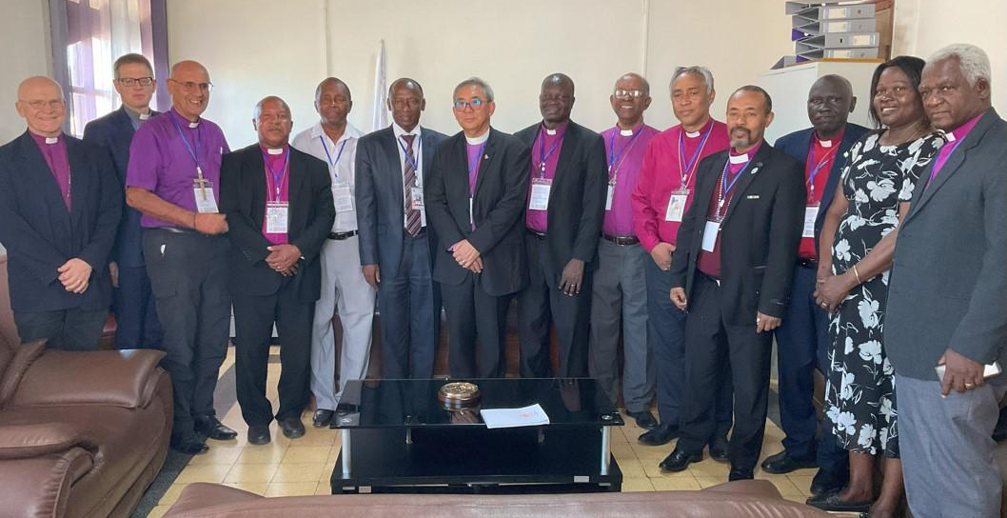
Official visit to the Prefet. L to R: Assistant Bishop of Sydney, General Sec. Of USPG, Hall, Bishop of Fianarantsoa, new Bishop of Antsiranana, the Prefet, Archbishop of the Indian Ocean, Archbishop Badi of South Sudan, Bishop of Toliara, Bishop of Antananarivo, Bishop of Toamasina , Bishop Poggo (General Sec. Of Anglican Communion, Fran Mates of USPG and Bishop Stenio of Mauritius.
The actual Synod was in the very expensive Hotel de La Poste. This I had researched on its website and was very excited by the beautiful swimming pool and wonderful menus. In actual fact we stayed in a slightly down at heel annexe with the food brought in by volunteers.
There was a splendid opening service in the large cathedral. This was my first visit there and, as elsewhere, I was impressed by how well ordered and CLEAN it was compared to Mahajanga cathedral. Archbishop James Wong gave a brilliant summary of the life of the Province since the last Provincial Synod ending with the news of a huge project for Solar Energy Farms spread throughout Madagascar giving light and energy to local communities and providing a large income for the church. I couldn’t help noticing that this was announced just before the election of a new archbishop or his own re-election for a further period of office.
The actual business of the Synod I was dismayed to find was totally dominated – almost to the point of exclusion – by a well-orchestrated attempt to get us all to sign up there and then to register as members of the Global South Fellowship. This would currently mean breaking links with the Archbishop of Canterbury on the grounds that he is no longer an “orthodox” Christian because of his voting in favour of the blessing of homosexual couples at the General Synod of the Church of England. It was stated several times by the Visitors – non-members of the Synod invited by Archbishop James – that the Archbishop of Canterbury approved of same sex marriage. I pointed out that this was not in fact true and the C. of E. had not changed its doctrine on marriage. Bishop Poggo, General Secretary of the Anglican Communion, intervened to confirm my statement but this was brushed aside by other visitors as a mere play on words. The Archbishop of the Sudan, sensing the mood of the synod, advised our Archbishop not to go to a vote but to send this issue back to the dioceses.
A major issue here is the understanding of what homosexuality is. The vast majority here, and in many parts of Africa, understand it to be a perversion chosen by individuals contrary to their natural instincts to relate to the opposite sex and is assumed to be totally promiscuous and the source of all paedophilia. So naturally it is seen as bad and shocking that it should be blessed in church. Trying to explain the understanding of homosexuality in other cultures, especially in the northern hemisphere, is an uphill and unpopular task.
The sticking point for most synod members was not the homosexual issue but the rupture with Canterbury and the Church of England both of which are much revered in Madagascar as the Mother Church and the source of great benefits. Bishop Samitiana of Toliara diocese summed this up well by saying that in Malagasy culture you regarded your parents as God-given gifts and, even if they went off the rails, they were still to be loved and cared for and never driven out.
Late at night the reports of the dioceses, to me the important work of the Province, were rushed through. We didn’t eat until 10.30 pm by which time one had little appetite for more business.
The Sunday was a very splendid affair revealing the comparative strength and wealth of the diocese of Antsiranana with the lengthy but very impressive service of consecration of the new bishop, the Rt Revd Dr Jaomandiny Jean-Baptiste. A massive congregation overflowed the cathedral and many watched the service on screens outside and on Facebook. Afterwards all were entertained to lunch for which four oxen were slaughtered. The VIPs had a very sophisticated meal in the cathedral hall. All very good humoured and enjoyable.
The next day we set off on the long journey back to Mahajanga. While we were en route we heard that the new bishop had, among many appointments announced on his first day, made my archdeacon, Eugène Tsifanavy, dean of Antsiranana cathedral. This is a huge honour for him bringing him back to his home diocese and close to his frail mother. This has in turn left me making a series of appointments – not yet complete.
Apologies for this being a long epistle but I wanted to give you a lot of information about what is going on.
In all the cut and thrust of everyday life I am finding the current lack of electricity AND WATER AND WIFI the greatest challenge I have had to deal with yet. I face a very busy period with the farewell to our archdeacon this Sunday, the retreat and Ordination of Priests the following Sunday and yet another meeting of the Archbishop and bishops the week after that….
Thanks, love and prayers to you all.
+Hall
hallspeers@gmail.com

21 June 2023

