In the beautifully long evenings edition, I mentioned that I had sneaked into Mother Jane’s pocket and had an exciting trip up to London. As I’ve got a few minutes spare between watching the finals on TV (definitely not the same as being actually there at Wimbledon) I thought I’d tell you a little more about my exciting day. It was very exhilarating if rather bumpy as we sped in the wheel chair pushed by Mother Jane’s son Chris over the potholes in the pavement. However, I soon found that there were compensations as the steward’s ushered us past the long queues to a special entrance for wheelchair users.
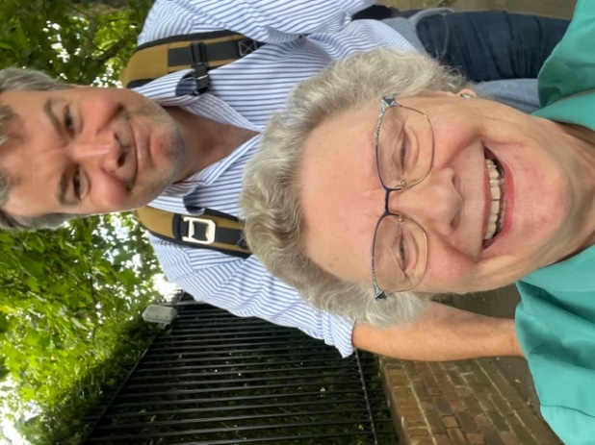
I took this picture sitting on Mother Jane’s hand bag as we bumped along she had to hold me very tightly so I didn’t end up in the road and get trampled on by the crowds of people all rushing towards the entrances. I was a bit concerned when I found our there was no cheese stall at the massive food outlet Beef burgers, chicken burgers, wraps, fish and chips but NO CHEESE.
Our seats were on the top floor so we had to go up in a lift the queue was very, very long but again one of the steward’s ushered us forward It appears wheel chairs get priority much to Mother Jane and Chris’s embarrassment. We were seated in a box specially designated for wheel chairs. There were lots of people in uniform looking after the audience our seats were under the care of men from Fire the Brigade. Just along from where we were sitting was a young man with several carers and he was there through Purple Heart wishes Charity.
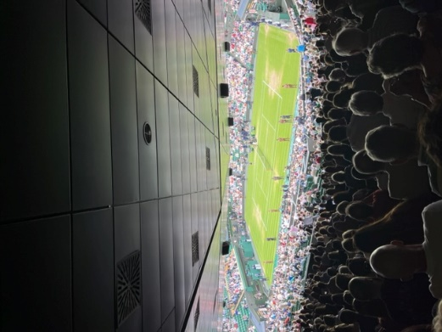
I was a bit peckish by this time, but Mother Jane had thoughtfully but some baby bels into her pocket. I don’t think she realised how difficult it is for a small hungry mouse to unwrap the red cellophane only to find that there was still another layer to get through before reaching the cheese.
It took me the whole of the first set (and it went to a tiebreak) before I eventually got to the cheese.
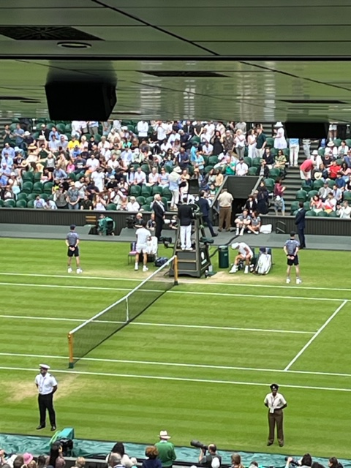

I mentioned the strawberries and cream and the champagne, but we also had the Pimm’s mixed with Champagne instead of lemonade. It was a fantastic day I spotted Queen Camilla in the royal box and Ben Stokes walked past us. And we watched Carlos Alcaraz win the quarter final. I came home a very tired happy mouse and chris gave me a very nice piece of stilton to nibble on the train!

