Our Mad Life 86
Winning and Celebrating
Although we have a grandson who is a keen footballer and I am patron of three football teams I had never been to a football match in my life until St James Church team reached the inter church league final. On a hot Saturday afternoon I found myself setting off with an excited team and a sheep (their mascot of the day); a chair for the bishop and sundry supporters. I was really quite anxious lest I disgraced myself by falling asleep. Our team, to my untutored eye, looked no match for the opposition who were much better built and stronger looking men. Some of our players looked as if they hadn’t had a square meal recently.
When the game began the opposition came thundering down towards our goal. I could hardly bear to watch the defeat. Our team suddenly took charge of the ball and a waif-like young man raced at astonishing speed passing the ball backwards and forwards across the pitch past the opposition who were slower movers. I was hooked, and went from worrying about falling asleep to wondering if my heart was really up to such excitement. Our team won very convincingly and at the final whistle I was dragged (willing but surprised) to the centre of the pitch where we formed a happy scrum hugging while prayers of thanksgiving were said! We then went back to church where of course drinks were on the bishop. So not my scene, but I loved it. However, in the speeches I was once again begged to buy shirts and shorts…

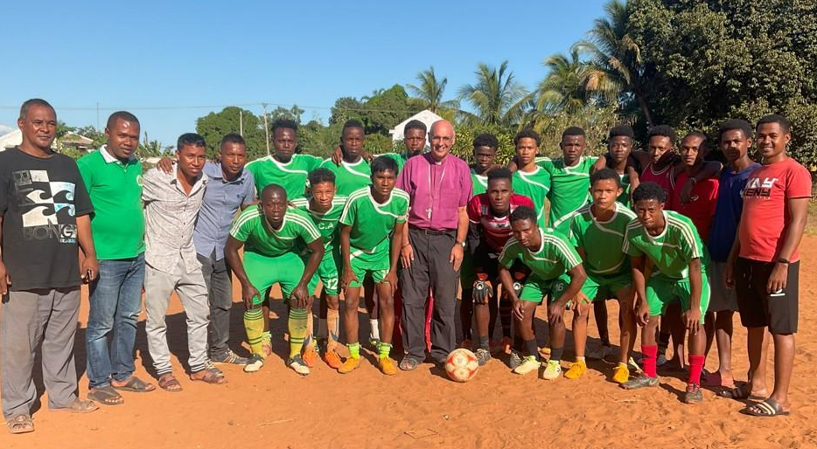
On the Sunday evening there was a big ecumenical pre-examinations service with hundreds of young people. It was my privilege to present the cup and a football to the runners-up. I illustrated my address with my newly acquired knowledge of football – a thing I never thought I would do.
The next two Sundays were also Youth orientated. First was the inauguration of a new Scout “Fivondronana” (literally: coming together). Nobody here has any concept of what might or might not be appropriate for a new memorial plaque in church, much less ask permission. So I was duly requested to unveil and dedicate a plaque to commemorate the event. I was not best pleased to reveal my name spelt incorrectly – all the more irritating as the plaque opposite had it spelt correctly. I was, however, more than happy with the parish lunch that followed: lamb in a rich coconut sauce. It was the football team mascot.
The next Sunday was Fathers’ Day which is a big event here. At the end of the morning service a very shy Sunday School girl was propelled in my direction bearing a pink heart-shaped cake to “the Father-in-God of us all”. Another parish lunch was followed by the Sunday School putting on a really beautiful show of singing and dancing. One of the many lovely things about it was that the children were having a great time, seeming to enjoy every minute. People love being in uniform and I was surprised to see that all the children had identical blue tee shirts and once more I was presented with one.

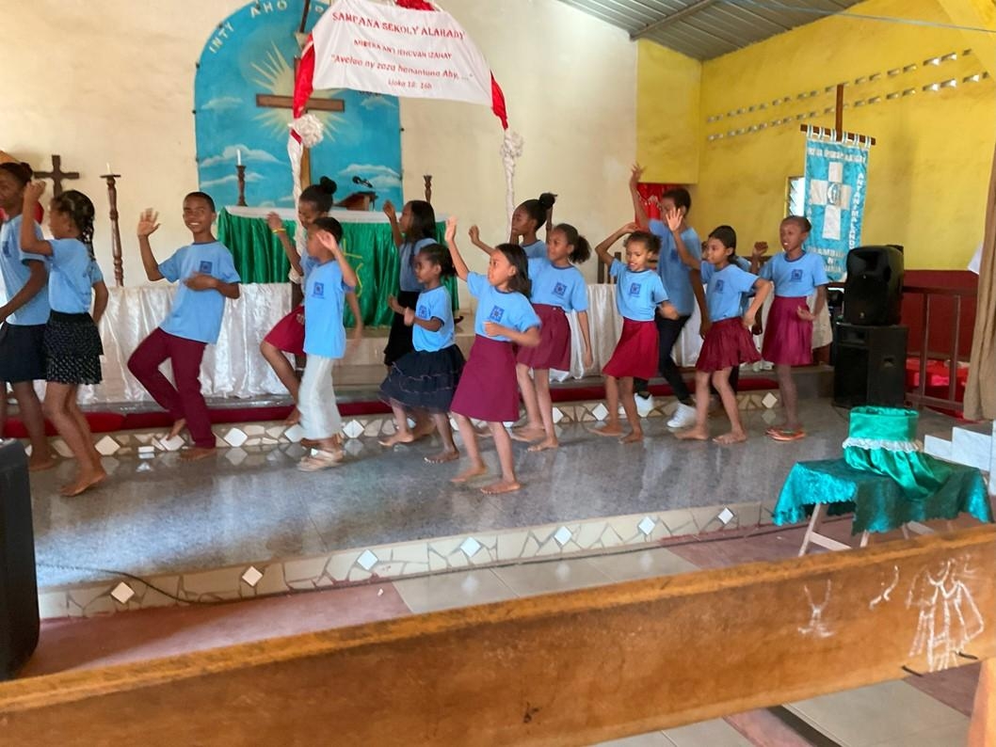
Afterwards we all sat down to refreshments and miniscule portions of the pink heart-shaped cake.
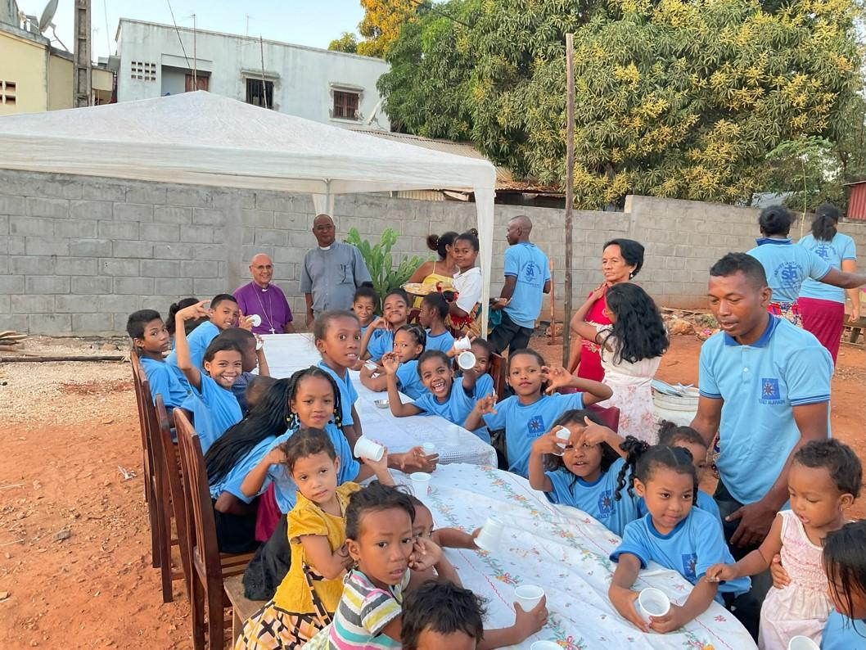

The working week days in between haven’t been much fun with the continuing unpredictable and lengthy power cuts. Zoom meetings are a lost cause. My printer keeps telling me that it wasn’t switched off properly, “please read the instructions”. Although I am adept at resetting the WiFi connection it is profoundly irritating to have to do it so frequently. Sometimes I just have it done when the power goes off again. The other night I just gave up trying to do anything when the light went off about 8 pm (having only just come on at 6 pm) and went to bed. I was fast asleep when my alarm went off but jumped out of bed immediately and pulled on some clothes and left the bedroom, to be confronted with my assistant Helarcin and the Vicar General and all the lights on. It wasn’t my alarm – they had telephoned me to wake me up as some urgent business had to be dealt with and nobody knew when we would have electricity again to do it. It was midnight. We worked until 3 am when the power failed again. That was OK except that we were getting up at 4 am to travel all day to an evening meeting which actually went on until midnight. I agree with the statement that sleep deprivation is a form of torture.
This last weekend has been yet another of celebration. I was immensely privileged to celebrate the 50th anniversary of my ordination by ordaining two priests starting with a refreshing retreat with the very hospitable Sisters of the Sacres Cœurs. A tiny frog shared the bathroom with me. This was certainly an ox lunch event and I decided that I should provide the ox. I am happy to report that at no point was I actually involved with the unfortunate animal. Before the retreat it was bought but it needed a passport to enter the city and that had not been issued so Helarcin’s wife, aided by the cathedral servers, was left in charge of meeting it at the police check-point at the city boundary and bringing it here. We returned from the retreat on Saturday morning to hectic activity at Bishop’s House. Some were chopping up the ox, some chopping firewood and lighting fires under huge cooking pots. As patron of the feast tradition dictated that I was the recipient of the liver and the tongue. What a massive amount of liver! Emilienne cooked me some tripe. I hate the look of it and don’t care for the taste of it but Emilienne was delighted when I suggested she take it home.
Guests were arriving. From then until now I have no idea how many people slept/are sleeping in Bishop’s House each night. I have clear guidelines: nobody is welcome in my bedroom, the second bedroom is for people I invite, the third bedroom and the rest of the house is available to bone fide attendees (and their children and their spouses) of whatever is taking place. Nobody but nobody thinks to inform me that they are bringing children or grandchildren!
The Ordination Service was a very joyful occasion. Immediately after their Ordination the new priests and their wives sang an anthem and the men, fully robed with their new red chasubles, danced to the delight of the congregation and the surprise of the bishop! No doubt helped by the invitation to lunch, we had one of the biggest congregations I have seen in the cathedral. A couple of hundred sat down to a beautifully organised lunch.
After all that I was practically in a state of collapse, but once more there was a summons from the Archbishop to attend a meeting in the capital so it was back in the car for the arduous journey. It is from Antananarivo that I write, immensely thankful to have survived and celebrated so much, not least 50 years of Ministry supported by Sarah first and foremost, and a great multitude of friends. Alleluia!
Bless you and thank you.
+Hall
hallspeers@gmail.com

7 July 2023

