Our Mad Life 87 B
No room at the Inn
The diocese has an accommodation crisis at the moment. Bishop’s house continues its dual role as my home and office and general diocesan (free) guest house. The latest resident/s is the new Vicar General(Commissary) and priest in charge of the cathedral, the Revd Gaston Onouree, with or without his wife and teenage children. On the departure of his predecessor the cathedral house was condemned as uninhabitable. The estimates for repair were considerably greater than the cost of a new house. Needless to add, there was no money to either repair or rebuild. So it was decided, after much discussion – and the cathedral committee has the stamina for endless discussion but not much action – to build a smaller house. This in turn ran into problems and landed back on my desk for the bishop to sort out. I got my faithful handyman/small contractor and a ladder and we did our own assessment. The cathedral committee was so shocked by the sight of the elderly bishop on the house roof they were ready for anything. I decided that, in spite of one contractor stating that the house was on the point of collapse, it was a repair job. Expensive, but nothing like the estimates I had already seen.
Off with the rusted corrugated roof. What was no good there was suddenly useful roofing wanted by certain members of the congregation. Meanwhile the Evangelist and assistant at Morarano school was homeless and he and his extended family had moved into a classroom at the church school while the school is on holiday. We are constructing a “semi-permanent” house with walls made from the deanery roof corrugated iron. Nail and rust holes in the walls aren’t so much a problem in the rainy season as they are in the roof! I have, with your help, bought new corrugated iron for both houses’ roofs.
The priest’s house that the Rev Gaston and family were in at Marovoay also needs urgent repair before a new priest can move in. Just to add to housing woes the bishop’s house roof needs urgent repairs before the next rain.
The wonderful thing about this roofing crisis is that we have a window of three months guaranteed not to have a single drop of rain.
In order to save embarrassment and general dislocation of my hosts’ lives I have a rule that I stay at the local hotel when I visit the churches round the diocese. Almost everywhere in Madagascar has a ‘hotely’ but that ranges from grand eye-wateringly expensive luxury hotels part of the well known international chains (payment in US$), mostly in the capital, to a table and a bench where you may be allowed to sleep. My booking is made through the local church a long time in advance. Mahajanga city has hundreds of hotels catering for all tastes and pockets.
I have just returned from a confirmation in Mitsinjo. On hearing that the bishop’s car was going there the cathedral Outreach/Evangelisation group decided to come too so sixteen of us and a mighty pile of luggage assembled on the quay side before dawn for the departure of the early ferry.
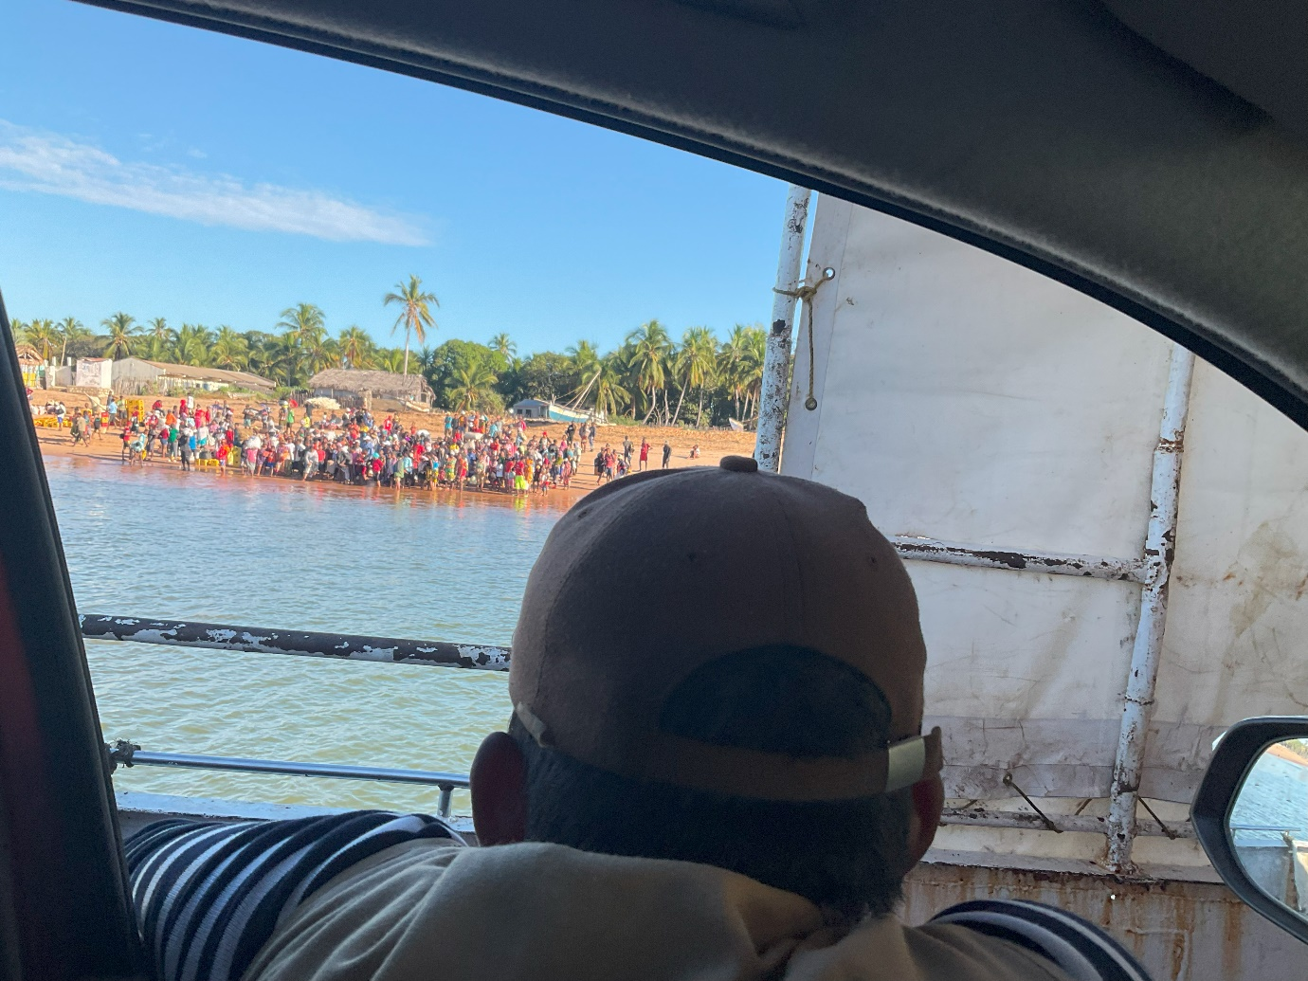
The Passengers waiting to board the ferry.

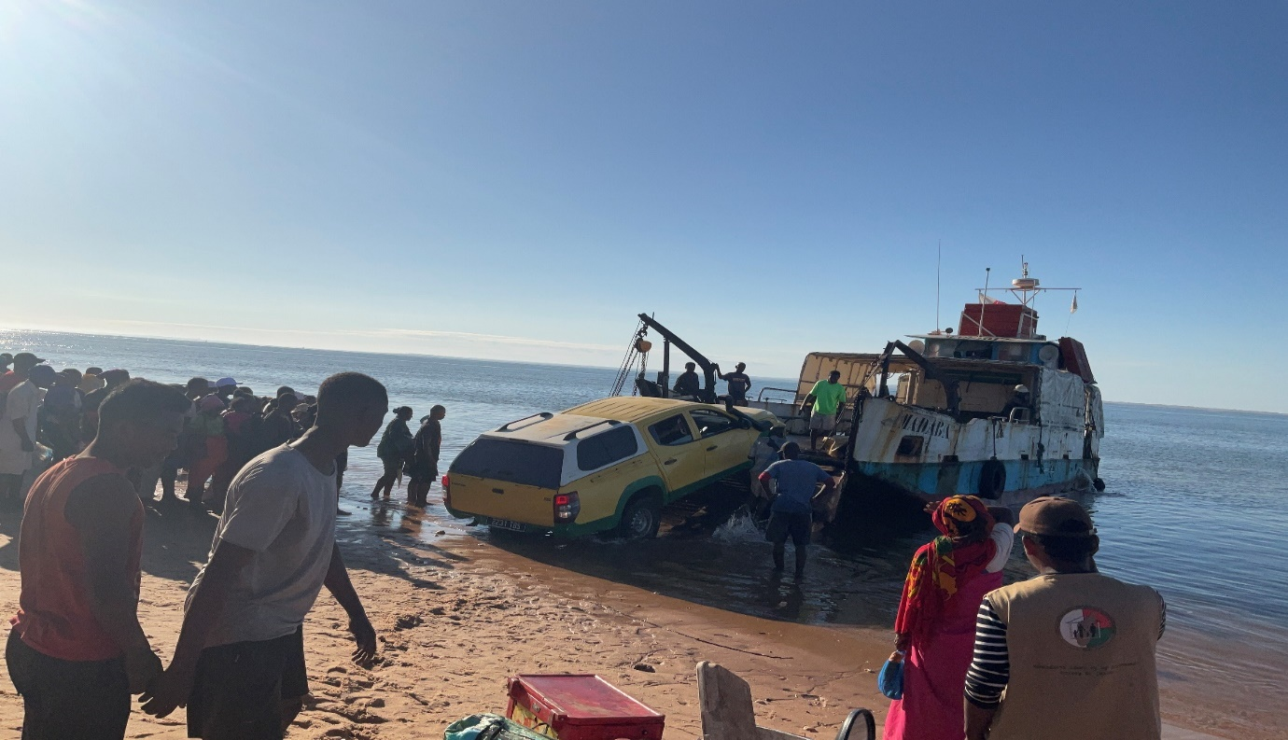
The ferry took 2 vehicles, 100 passengers and a huge amount of rice and charcoal. I didn’t enquire about the risk assessment!
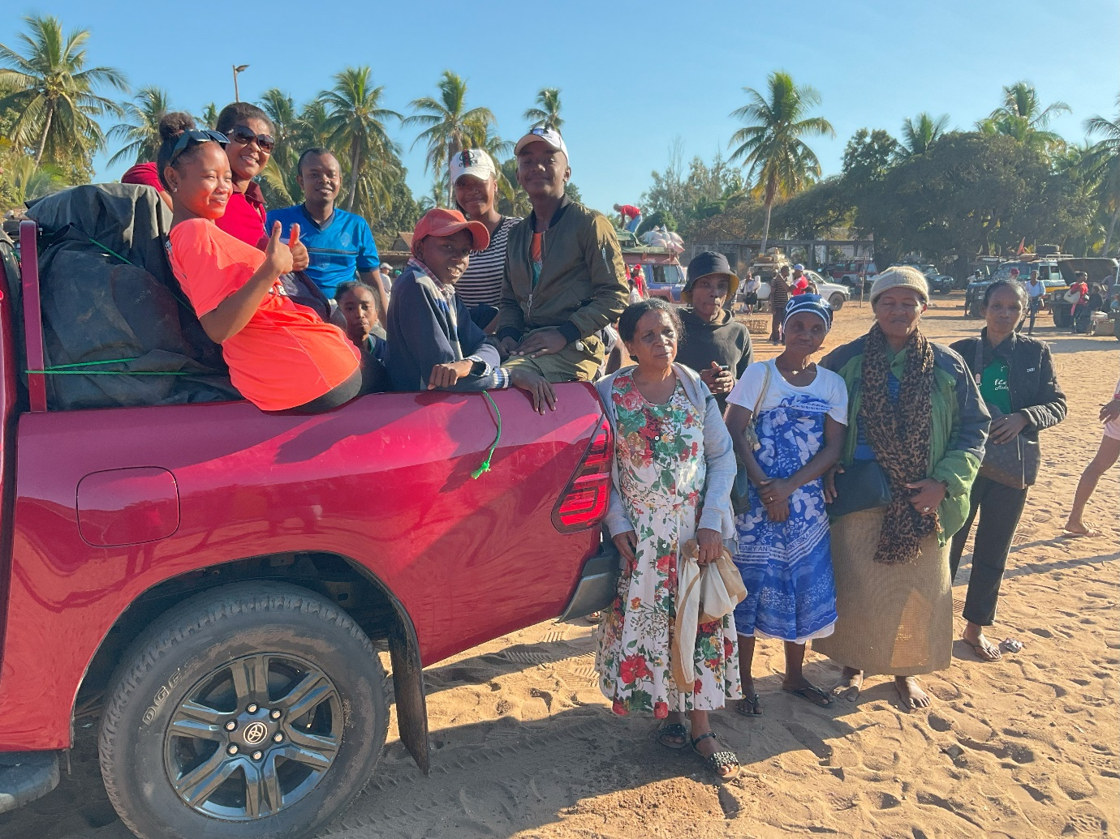
The cathedral outreach/evangelisation committee after the ferry trip. Note the road surface.
As we are now in our sixth month without rain the dust clouds created by a vehicle on the earth roads are so dense one cannot see a vehicle in front. Since we only overtook 2 vehicles in five hours this was not a huge issue. However, when we slowed down suddenly we were enveloped in our own dust cloud. I was amazed how unfazed by this all our passengers in the open part of our vehicle were.
I was asked about parking the car. Would the fore court of a house be acceptable? I didn’t see any problem. What I hadn’t been told was that the room that had been booked for me at the hotel where I stayed last time was no longer available. What did I think about such and such a place? I replied that I couldn’t say until I saw it. I set off with a quorum of my entourage to inspect the room. I was preceded to the room by a small procession carrying my considerable luggage. The room in question was spacious and clean. To my surprise my host and colleagues disappeared off and came back saying that the room was unsuitable.
There was no light, no water and no sanitation. It is a “bring your own bucket with lid” room. Water for washing? Not included. “You just stay in the room and have a siesta and we will see what else is available”.
Four hours later my troops returned with the message that there was no room in the inn anywhere in Mitsinjo – suitable for the bishop – but they had negotiated with the RC priest to free up a room at their school which the ladies in the party had cleaned. Communal washing facilities (buckets of water) and toilets were at the end of the corridor. This room was suitable for me but not for Malagasy as they knew I wouldn’t fuss about the lack of a door that closed while they wouldn’t sleep in an unlocked room! Never mind the fact I was carrying several million ariary to buy land. And so at last to sleep after a very long day.
The telephone aroused me from my slumbers and put all the accommodation issues into perspective with the tragic news that the Rev. Helarcin’s sister had died in childbirth. She had been part of the happy party at Bishop’s House so recently as we celebrated the ordinations and she seemed to be in perfect health. Helarcin left immediately that night to join his family – a two nights and two days’ journey.
There is no resident clergy person in this part of the diocese so that left me on my own to do the baptisms and confirmation. The local catechist/reader (who supposedly made my hotel booking) who in is charge of the church and who “organised” this visitation seemed incapable of working out who was being baptised in spite of many phone calls. Meanwhile the land purchase which supposedly had been arranged for Friday morning was the source of phone calls and no action and, final straw, the permission for our Outreach group to use the town hall and borrow loud speakers had also not been done.
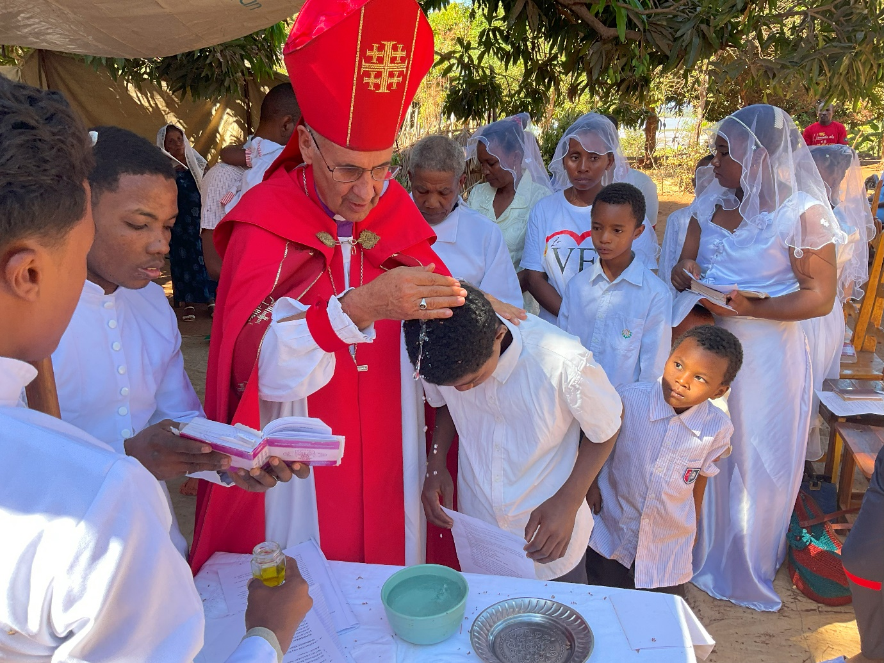
On Sunday morning we were all up early to erect a sanctuary of tarpaulins and so began the service of Baptism and Confirmation and Holy Communion. The photograph above shows the baptism group under a huge mango tree. While waiting for the feast of goat meat afterwards the children all crowded round me and we spent a happy half hour looking at photographs. On the Monday we were all up at 1 am for packing and a 2 am departure.
I am now back in Mahajanga and very thankful and happy to be so! As always, so much to be thankful for. Praise God and thank you.
Yours
+Hall
15th August 2023
hallspeers@gmail.com

