Our Mad Life 88
The Mothers’ Union Zaikabe
Plotting, organising, re-organising and spending in preparation for the Mothers’ Union Zaikabe (Triennial National Conference) in Fianarantsoa has dominated and dislocated my life for weeks.

Plotting: because it was my privilege to invite and partially coordinate the visit of Bishop Rose of Dover. This was agreed by the bishops of Madagascar after the Archbishop refused permission for her to attend the provincial meeting. The MU Zaikabe is the biggest event in the Madagascar church calendar this year with all the bishops of Madagascar in attendance. People knew I was busy arranging visits but names were not revealed!

The Zaikabe was due to open last Thursday, 24th August. Unfortunately the visitors from Canterbury couldn’t come in advance of the Zaikabe and thus I had to arrange flights from Antananarivo to Fianarantsoa. Also coming were the MU Worldwide President, Sheran Harper, and council members from Cameroon and Uganda and staff from London. They got their bookings done first and hired a MAF (Mission Aviation Fellowship) aeroplane on the Wednesday afternoon. I managed to book the MAF aeroplane on the Thursday morning departing 7 am to get Bishop Rose to Fianarantsoa just in time for the opening ceremony. However, it was a small plane and the passengers’ body weights were included in the luggage allowance. So it was arranged that I would see the visitors on to the plane and travel by car with their luggage thus missing the first day of the Zaikabe myself.

At the last minute MAF rang me to say that the pilot couldn’t manage my booking and they were putting the visitors on the morning flight the day before. I pointed out that was impossible as they would not have arrived in Madagascar by then and, secondly, the whole point of their coming to Madagascar was to attend the meeting. I was really cross, anxious and embarrassed - and let it be known that I was so. MAF rang back and asked if I was prepared to hire a bigger plane on the Thursday morning, mindful that the whole trip was weather dependent and Fianarantsoa airport is often shrouded in clouds at this time of year. With much dread I said “Yes”. How much? 10 million ariary!!! I calculated that if I borrowed ALL the money in the various accounts I could just about pay and hurried to the bank and did several transfers. (In the event Canterbury footed the big bills).

And so, once more the tedious trip to the capital, a night with the Sisters FMJK, and on to the international airport to welcome the visitors. What a joy and relief to see Bishop Rose and her colleagues from Canterbury, the Rev Carol Smith and the Rev Andy Bawtree, and bundle them into my car and take them to their hotel for the night.

My driver and I were back at the hotel at 6 am to collect them and their luggage. Since we were now travelling in the bigger plane I too could join the flight and take all the luggage. Bishop Rose is one of those wonderful outgoing personalities whose smiles and greetings attract attention in the nicest possible way. She was delighted when she was invited to sit in the co-pilot’s seat for the flight.
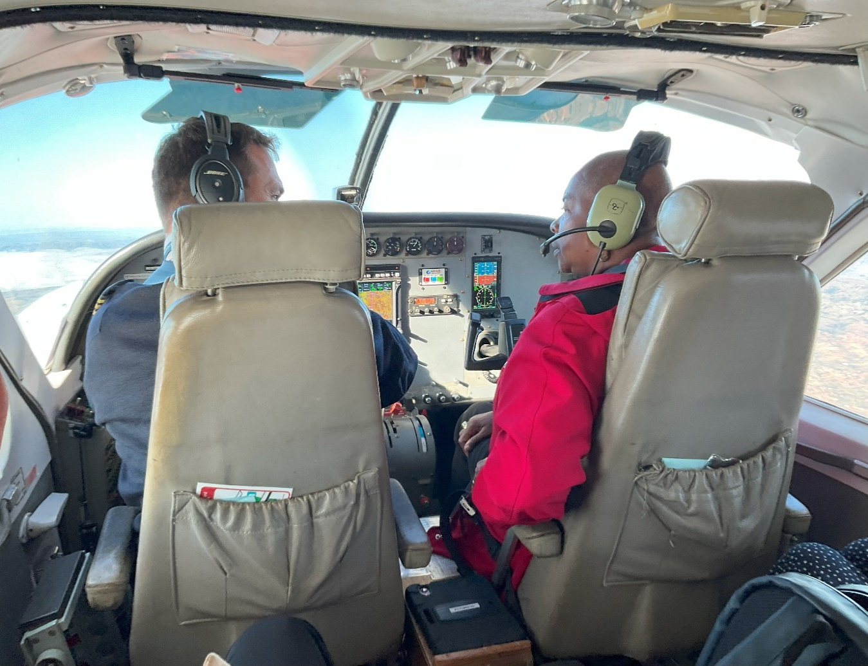
Bishop Rose at the controls deep in conference with our pilot.

It was a glorious sunny winter morning and we arrived in Fianarantsoa at 8 am and amazingly were robed and ready for the opening service in the cathedral at 9 am. Only when Bishop Rose took off her mitre and got into the pulpit and spoke did the penny drop to the 1,000 plus ladies in the cathedral that the Bishop of Dover was a black WOMAN. There was a mighty wave of gasps and murmurs across the cathedral. “Yes, the bishop is a woman” proclaimed Bishop Rose. What added to the shock amidst a congregation of women with universally long hair, not to mention wearing veils, was Bishop Rose’s extremely short hair (and no veil in sight). Everyone hung on every word – or the translation. Which meant every statement had two waves of reaction – a little one to her words in English and a big one to the Malagasy translation. Bishop Rose outlined her life story before commencing her sermon on the Zaikabe theme of “A new person in Christ” (2 Cor. 5. 14-21) with the slogan “Change now!”.

Meanwhile distress calls were coming from the Mahajanga cathedral members. They had hired a bus leaving the cathedral on the Monday night. The day before the driver cancelled. There was a desperate search for another bus and driver which was eventually found on condition they paid a large deposit and it was agreed to depart on Tuesday morning. When the time arrived he also cancelled and refused to return their deposit. A deputation went to the police and got a friendly commandant and leading members of the cathedral to accompany them to the bus company, a bus co-operative, and they got their money back. A third bus was booked and eventually they set off. They missed the first day of the Zaikabe and didn’t arrive in Fianarantsoa until midnight.

Everyone was struggling with the logistics of the Zaikabe. Grumbles about food or lack of it, the clergy struggling to distribute communion to such numbers, etc. I was the celebrant at the service on the Friday morning and the time was brought forward by half an hour as everything was taking so long. That morning we had over a thousand communicants.

The bishops took it in turns to chair a session. Mine was on gender-based violence. I was not coping with the severe drop in temperature and by then I had a cold. By the time the House of Bishops met in the evening it was the worst cold I have ever had and, among many other symptoms, my ears were blocked. The bishops met from 5 pm until adjourning for dinner at 9.30 pm by which time I wasn’t interested in anything except bed and could scarcely hear.

Worse was to come. Bishop Rose suffered a violent stomach upset and diarrhoea in a room with no water. On Saturday morning a special train took those who could afford it for a picnic in a tea plantation. Neither Bishop Rose nor myself were in a fit state to leave our rooms and the contingent from Mahajanga couldn’t afford the fare and most, like me, were suffering from the cold. My Emilienne and others visited me and fed me with fresh ginger, lemon and honey. Emilienne said I should wear at least two pairs of trousers and as many shirts as I could. She had clearly taken her own advice and was quite a sight: leggings, skirts, dresses, jackets…

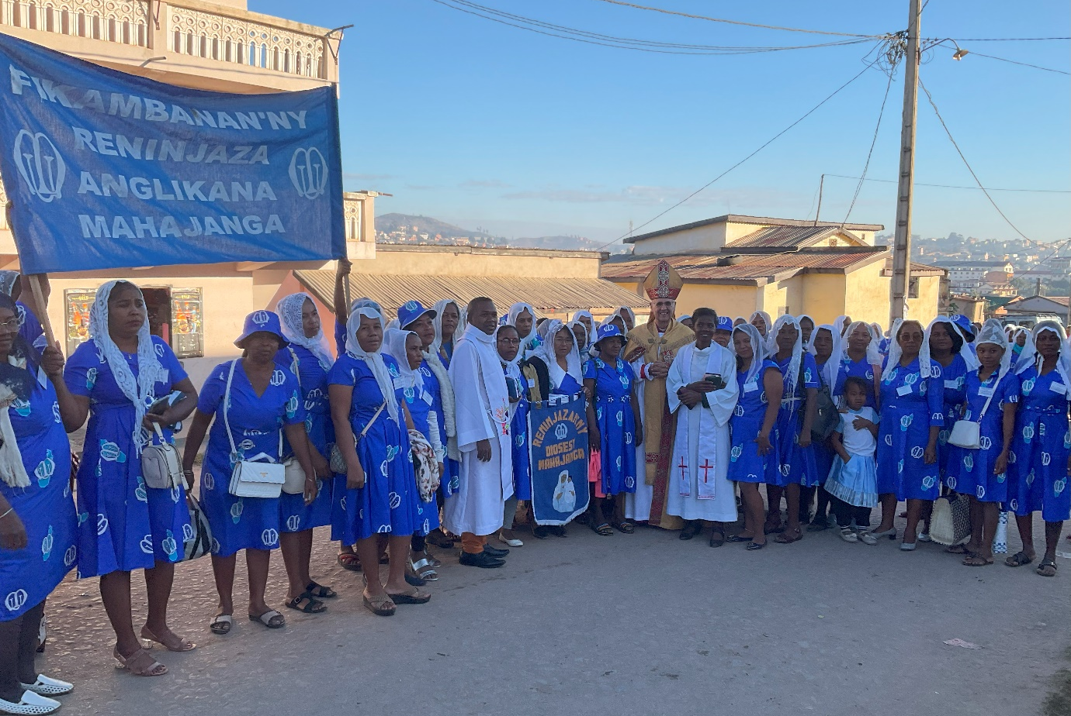
The Mahajanga contingent.

By Saturday night I was ready to face the world again but sadly not Bishop Rose who was looking very weak indeed and still confined to her room. Thus she missed the most spectacular event of the Zaikabe – the great procession before the closing service. I don’t know how the starting point was chosen but it was a considerable distance from the cathedral and I was quite relieved to have been driven there.
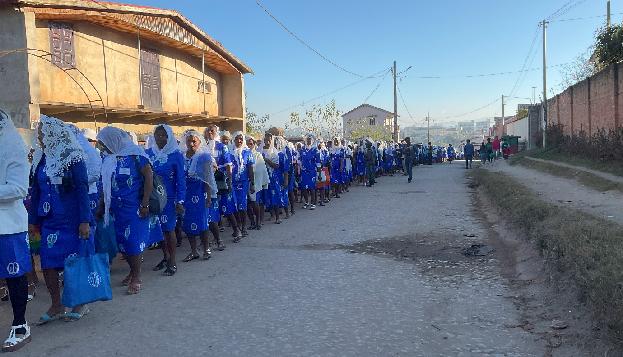
A tiny section of the procession

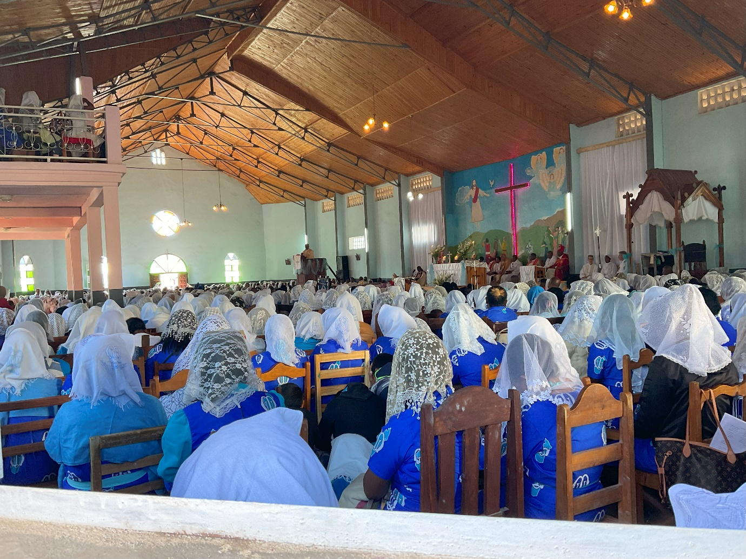
The multitude in the cathedral

The service was tremendous. The singing was loud and joyful, the offertory was another long procession as everyone processed and danced with their donation and there was a powerful sermon by Bishop Gilbert of Fianarantsoa. Then there were speeches and presentations that lasted almost two hours. The speeches were limited to three minutes each but the Worldwide President alone took up 30 minutes! The newly elected national committee was presented and blessed. And then the photographs – another hour.
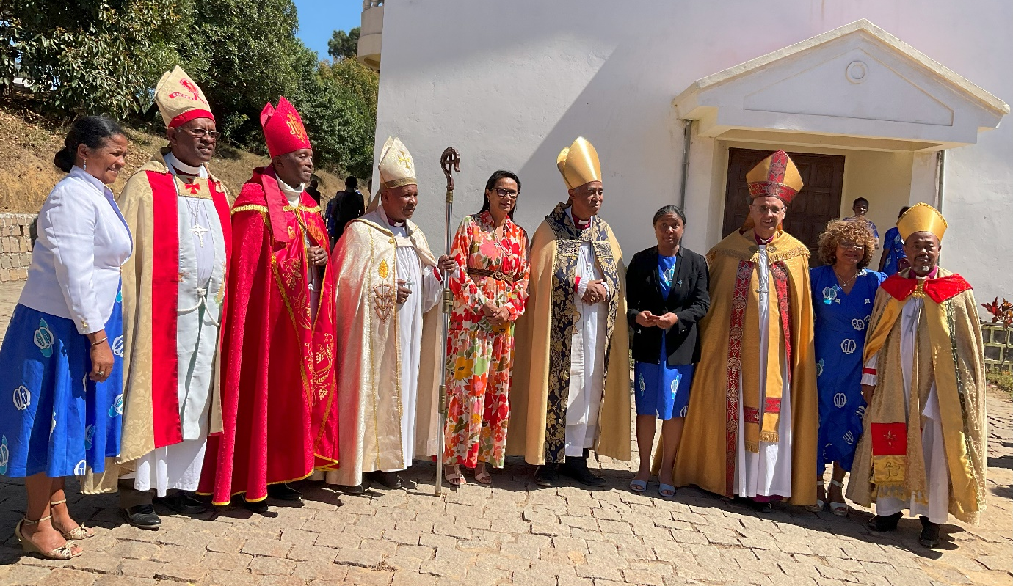
The bishops with the Prime Minister’s wife in the centre.

Lunch for the VIPs was a very splendid meal. I had the pleasure of the company of Sheran Harper and Naomi Herbert from Mary Sumner House. However, many, including myself were clock watching as we were anxious to be on the road as soon as possible. I had to have the priests from Canterbury back to the capital for their flight to England the following day. I didn’t get to bed until after 4 am.

An experience not to be missed but also one I am glad not to have to repeat!
Love and prayers from one very tired bishop, thankful to be back in Mahajanga in the heat of 34 degrees.
+Hall

hallspeers@gmail.com

29 August 2023

