Our Mad Life 89
Bishop Rose
“What keeps you going? What sustains you?” Bishop Rose asked me very soon after arrival. Typically her, she goes in deep more or less straight away – and fearlessly.
The radiant larger than life character arrived at Mahajanga airport on Saturday evening, 2nd September. Originally, she was due to spend the day with us and we had planned a prison visit knowing of her projects to improve justice in many places. Instead it was after dark when the plane touched down but the cathedral committee turned out in force to welcome her and see her to Bishop’s House. Knowing that she had just had a violent stomach upset I was playing safe and taking her to the Coco Lodge, a European style hotel with an extensive menu, for dinner. I also invited Vanilah, one of the young ladies from St. James’ Church, as her spoken English is excellent and she was going to translate the sermon the next morning.
The hotel staff were intrigued by the strange trio and the service was excellent. I was taken aback when +Rose announced that the meal was on her as she couldn’t come to my farewell and this was her thank you to me! It turned out to be a superb meal and after delicious but rather small starters +Rose tucked into a huge lobster and declared it to be the best she had ever tasted outside Jamaica. (Jamaica is the gold standard for the ‘girl from Montego Bay’.) She summoned a waitress to tell the chef and seemed to effortlessly break through the language barriers of Malagasy and French with clear English and happy gestures. Vanilah and I were equally happy with our choices. The evening concluded with +Rose’s first journey by tuctuc back to Bishop’s House.

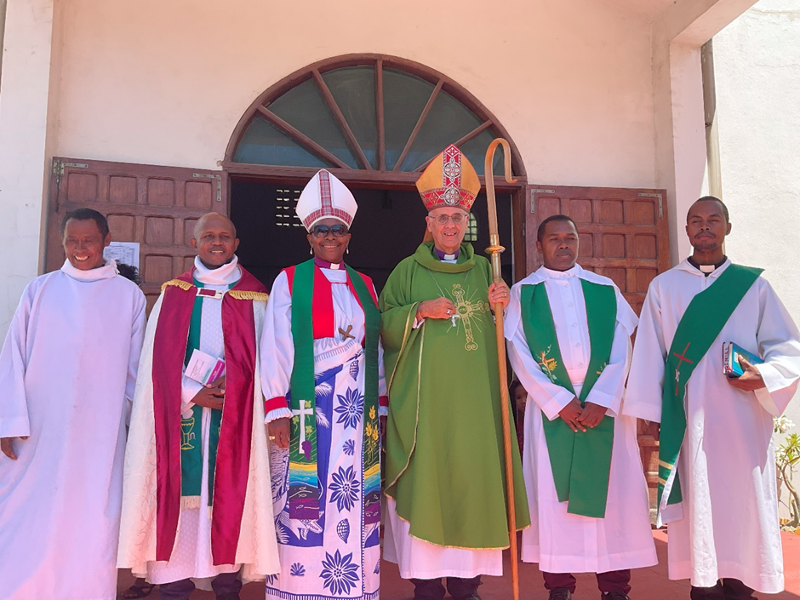
Left to right: cathedral catechist, Dean Gaston, +Rose, +Hall, Rev Helarcin & Rev Jean de Capistran

Predictably, Sunday morning was a Sung Eucharist at the cathedral with +Rose preaching. While waiting for the service to begin she had a wander round and was shocked by the living conditions of the cathedral on-site staff. “An eye opener.” The disparity between the buildings and facilities at Fianarantsoa, Toliara and Mahajanga diocese were not lost on our guest. Mahajanga is the only diocese in Madagascar that has no buildings other than the churches and a few clergy houses.
+Rose entered the pulpit with a broad smile, outstretched arms and a loud “Salama” (the equivalent of Hello there!) immediately engaging the attention of the congregation.
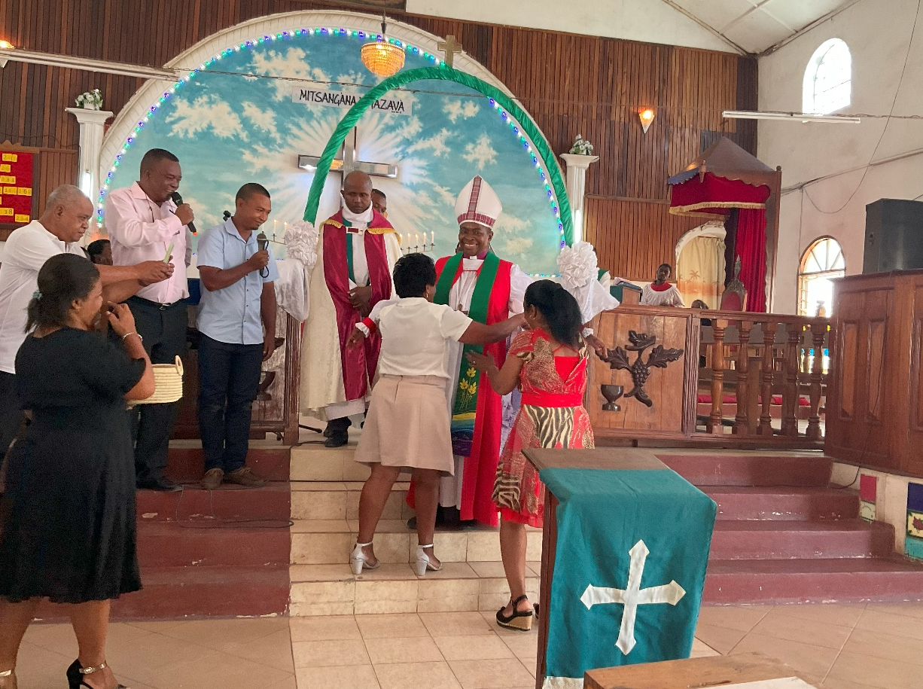ing Being Being presented with a lambaone
After the usual long photocall at the end of the service – everyone wanted to be photographed with the bishops – there was a “cocktail” at Bishop’s House. ‘Cocktail’ in this context means a reception with generous nibbles and soft drinks. Nothing that I would call a cocktail! Those invited tucked in as if it was instead of lunch leaving the bishops to chat to each other, which was fine by me though I was a little disappointed that no one made the effort to talk to our guest.
Lunch was different. As +Rose and I sat at our table I remarked that it felt like speed dating as the other chairs kept being filled by different people, each ready to engage in deep discussion. It was a delight to observe. +Rose seemed to have an instinct to call out some unreformed male attitudes taking our companions by surprise by pointing this out.
Equally startling was when she asked a teenager if he was going to go forward to ordination. There had been no lead up to this what so ever. A week later he is busy filling in his application to enter theological college next month. (He and I had previous conversations.) +Rose proved to be a remarkable catalyst.
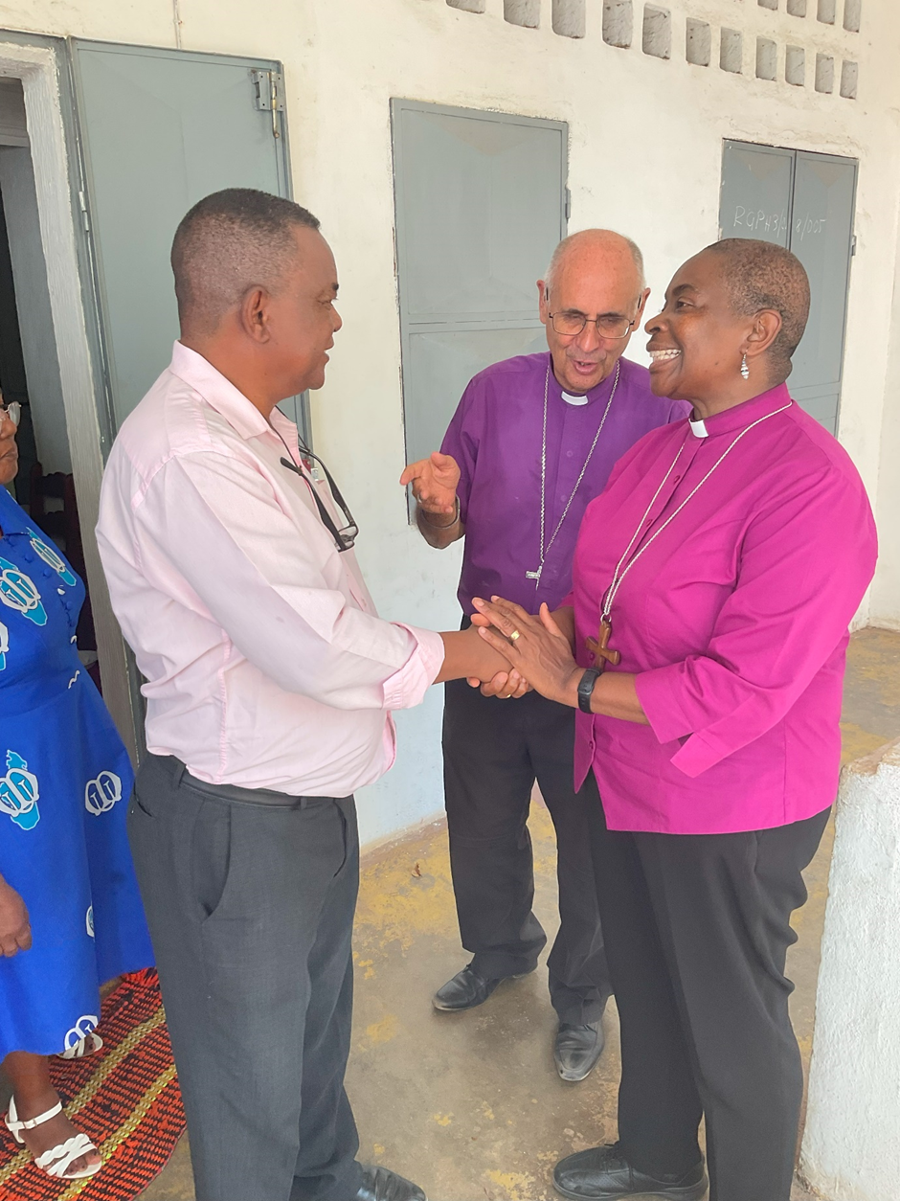
Meeting the chairman of the Cathedral Committee
Madagascar Airlines sent a message saying that +Rose’s flight from Mahajanga was delayed until 11.30 pm. It was a joy to have her for the rest of Sunday but a huge anxiety as it left only enough time for an overnight drive to the capital to catch her Monday midday flight to England. So we set off for the airport prepared to drive all night if the flight was cancelled. To everyone’s relief the flight took place and +Rose got to the capital at half past midnight at the end of an exhausting trip to Madagascar and it was good to receive her text late on Tuesday night saying she was safely home.
So what sustains me and keeps me going? It sounds trite, but I am quite sure it is the power of prayer. I am deeply conscious of how many hold me in their prayers daily. What a privilege. Thank you.
A lot more prayer is needed to see me through the rest of this month as we see the Ordination and Evangelist candidates off to college and I lead the clergy and wives in-service training programme and diocesan synod! I feel ill prepared and quite exhausted at the thought.
But as always, the big message from me to you is quite simply, THANK YOU.
+Hall
11th September 2023
hallspeers@gmail.com

