Our Mad Life 90
Turbulence
I am delighted to report that we have had a very happy clergy and wives In-Service training week followed immediately by residential Diocesan Synod.
Prior to those I had a nasty attack of Meniere’s disease. During a meeting of the development committee, I had to lie flat with my eyes shut to stop attacks of rotary vertigo. In spite of the bizarre situation of the bishop in bed with the various worthies seated around we got on with the work. However, these bouts leave me without any energy and needing to rest after anything and everything.
The In-Service training session as last year was held in the idyllic beach location of Notre Dame des Flots at the popular Petite Plage on the northern side of the city. The weather was perfect and all our sessions were held with the backdrop of swaying palms and blue sea with sailing boats fishing in great numbers. The catering was good with absurdly generous portions and much appreciated by all, especially the ladies. The men all claimed to be tired and were much preoccupied by the prospect of life without the current bishop. The clergy were shocked when I laughed when they presented me with several copies of a petition signed by them all. They unanimously decided that they wanted another “strange bishop” (‘strange’ being their translation of ‘foreign’): Irish or English (by which they mean British), American, or Canadian – in that order of choice.
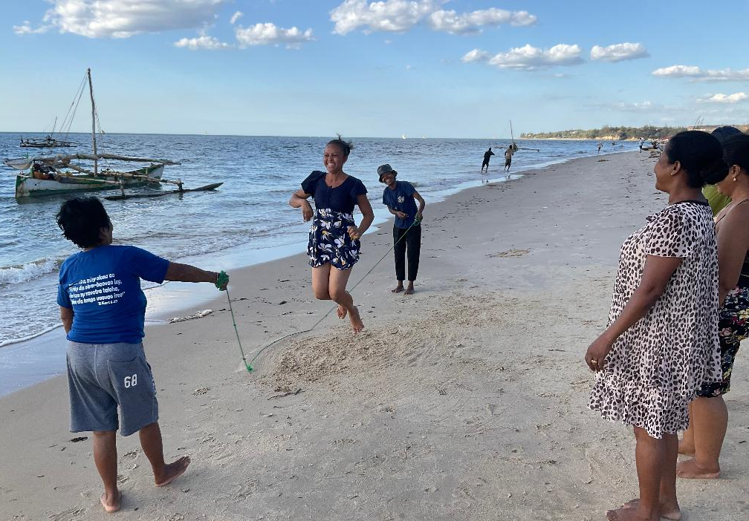
Clergy wives having fun
Synod was going along merrily until we reached the vexed question of clergy pay and the parish quota/share needed to provide it. The clergy and laity met separately. The clergy very efficiently did calculations as to how much they needed and it was agreed that the basic stipend needed is 400,000 ariary per month (£80). The laity were dominated by the representatives of the two wealthiest congregations in the diocese and decided on 250,000 per month (£50). The clergy pointed out that 250,000 ariary is the minimum legal wage for an unqualified worker… To my astonishment, in the face of intransigent laity, the clergy agreed to the minimum wage on condition that it is recognised that they need to seek other employment to supplement the stipend. I pointed out to the laity that this meant that the diocese did not have a single full-time priest. “So what? Times are hard.” Then came the bickering over which parishes paid what percentage. Another set of unsatisfactory compromises were made. I found all this extremely stressful and the clergy were very concerned that I was taking it too much to heart!! “Don’t worry, Bishop, we will survive.”
When the Dean of the cathedral announced that it had been a wonderful Synod led at all times by the Holy Spirit I begged to differ. Some of the discussions and decisions were indeed inspiring but I couldn’t agree that that was true of the stipends.
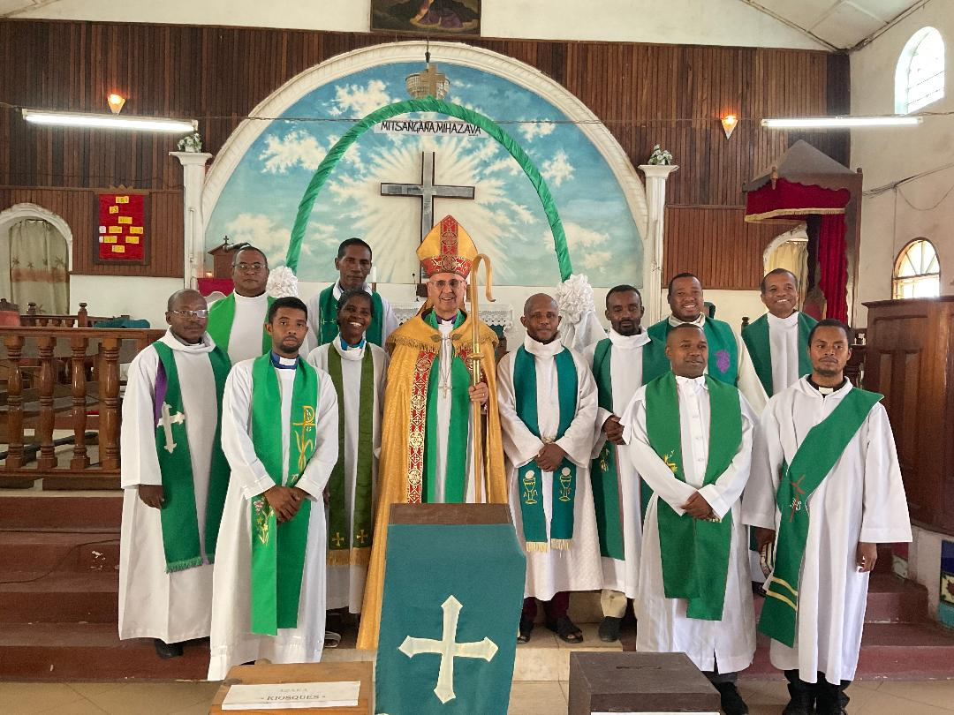
The diocesan clergy
I knew that I would need a break after all that and had booked the inside of a week at a beautiful beach hotel with my sister and cousin who were visiting me. The location was picture perfect, the pool a delight and the food good but I was more in convalescence than holiday mode.
Next on the agenda was a Confirmation at Mandritsara requiring a two day bumpy drive up into the mountains in the north east.
However, all this year in the background have been rumblings about the forthcoming Presidential elections. All the candidates came together and have made a legal challenge concerning the validity of the fast approaching elections. Among other things it has been pointed out that, according to the constitution of Madagascar, the candidates must be holders of Malagasy passports. The current president and front runner candidate applied for and received a French passport which automatically annuls his Malagasy citizenship. Demonstrations have taken place and the opposition candidates were tear gassed at one event resulting in one currently being abroad for treatment to damaged eyes.
The date of the election was the date we had unwittingly chosen for Sarah and our daughter Ishah to arrive for my official farewell. The Archbishop in the Seychelles and the bishop of Mauritius decided it was unsafe to come. And the bishops of Fianarantsoa and Toliara rang me and advised me to leave the country sooner rather than later. Sarah quickly arranged for me to fly back to England 24/25th October.
I carried on with the Confirmation at Mandritsara. The poverty of candidates shocked my Malagasy colleagues who had travelled with me. Most were barefoot and their clothes rags by anyone’s standards. I found this all the more touching as they joyfully made their promises and sang endless hymns. When I presented them with Bibles many were visibly moved.
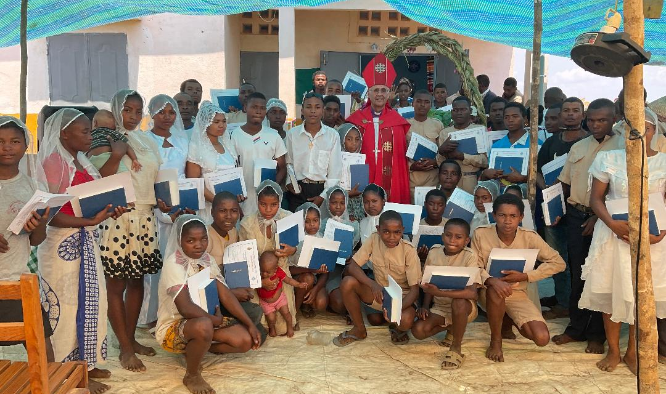

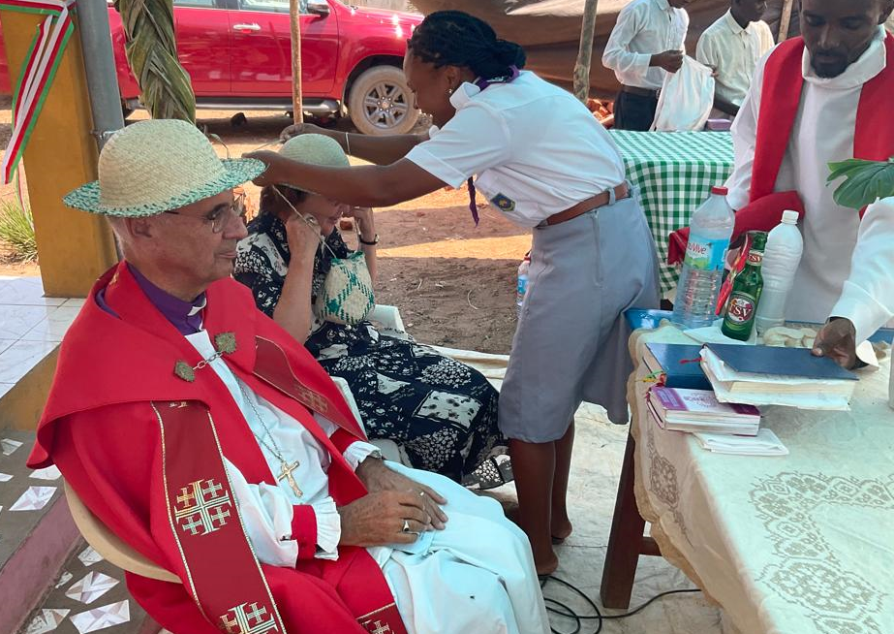
Presentation of hats
Meanwhile my sister Anne joined me on the trip and was anxious to see the slaughter of the ox for the feast. She was absolutely horrified by it, never having witnessed such wanton brutality and suffering of an animal. She explained to several people that, quite apart from the suffering, the quality of meat from a highly stressed animal is very much inferior to what it should be. This surprised them.

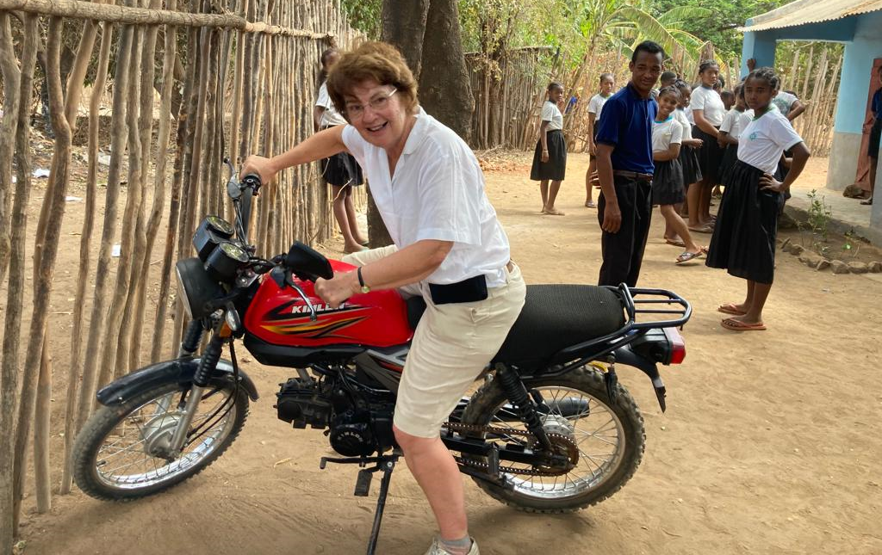
Anne trying out the Archdeacon’s motor bike
Back to Mahajanga and the patronal festival of the cathedral, St Luke’s. I will conduct a Confirmation on Sunday morning and leave here early Monday morning en route to England.
We pray that the election when it happens will be peaceful - contrary to all indications.
My current plan is to return to Mahajanga and finish my Confirmations and have a formal farewell in 2024.
With the bombing of the Anglican hospital in Gaza, the Ukraine war, and political extremism almost everywhere it is certainly a time to appreciate peace, strive for justice and give thanks for where we are and what we can do.
Love and prayers
+Hall

hallspeers@gmail.com
19th October 2023

