Our Mad Life 94
“On a wing and a prayer”
Going to the destination of my choice at a time convenient to me in “my own” (i.e. Mission Aviation Fellowship) aeroplane is something that one could easily get used to! The aeroplane in question was a tiny Cessna and so I found myself sitting in the co-pilot’s seat which turned out to be rather fun. I had imagined taking off and landing to be rather scary. Not a bit.
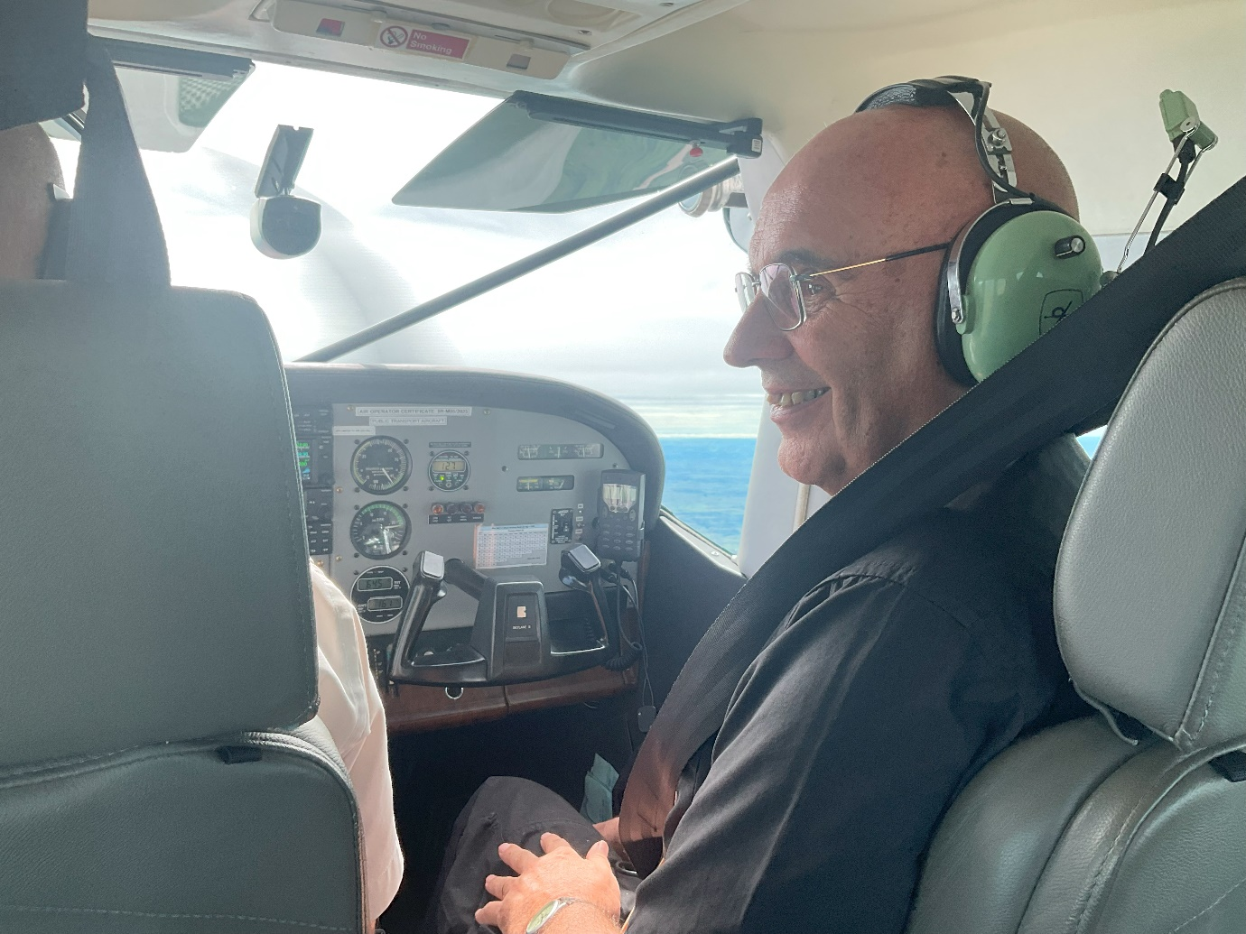
What was quite scary was flying straight into a thick cloud unable to see anything except our one big propeller whizzing round in front of us while watching the fuel gauge getting closer and closer to empty. I mentioned the lack of fuel to the pilot on landing. He laughed and said that we had enough for another 60 miles. This seemed a slim margin to me given the 100s of miles we were flying over uninhabited areas!
The Relay Trust meeting informed the bishops that their available funding was extremely limited at the moment and the promised grants would not be forthcoming this year. The entire budget allocated to Madagascar was less than what each of us was hoping for. This was a severe blow to all of us. Having bought land to build a fine training centre the diocese of Mahajanga is left with a small budget to do the training and nowhere to do it. (The other Malagasy dioceses already have their buildings.)
On with the Confirmation schedule. The archdeacon accompanied me to Maintirano in the far south west of the diocese. The Confirmation Service was to conclude with a procession to the opening and dedication of the rectory next door. On arrival we found that the rectory was far from complete and what had been done – at great expense – could only be described as a botched job. So depressing and infuriating.

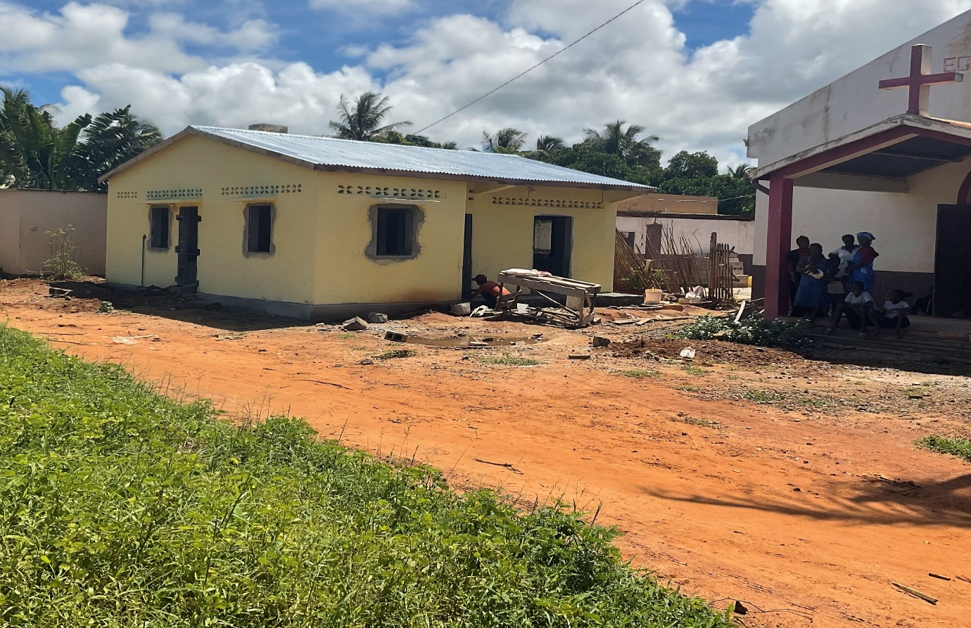The new rectory next door to St James’ Church, Maintirano
On these visits a lot of time is taken up with “Visites de courtoisie”. These involve speeches of welcome, signing a sort of visitors’ book and photographs. This time the Governor departed from the protocol to make a complaint about the lay Reader at the church. It sounded to me like a family squabble, a clash of personalities in church and a few errors hideously intertwined and I braced myself for listening to ‘the other side’. Indeed two more prolonged sessions followed revealing more problems in the parish.

I was received by the deputy Mayor as the Mayor, like a great number of the population, was suffering from conjunctivitis.
Next was a visit to the Préfet. I was very warmly welcomed when I told him that I had visited his old school at Ambatomanga and ate the cheese produced there.
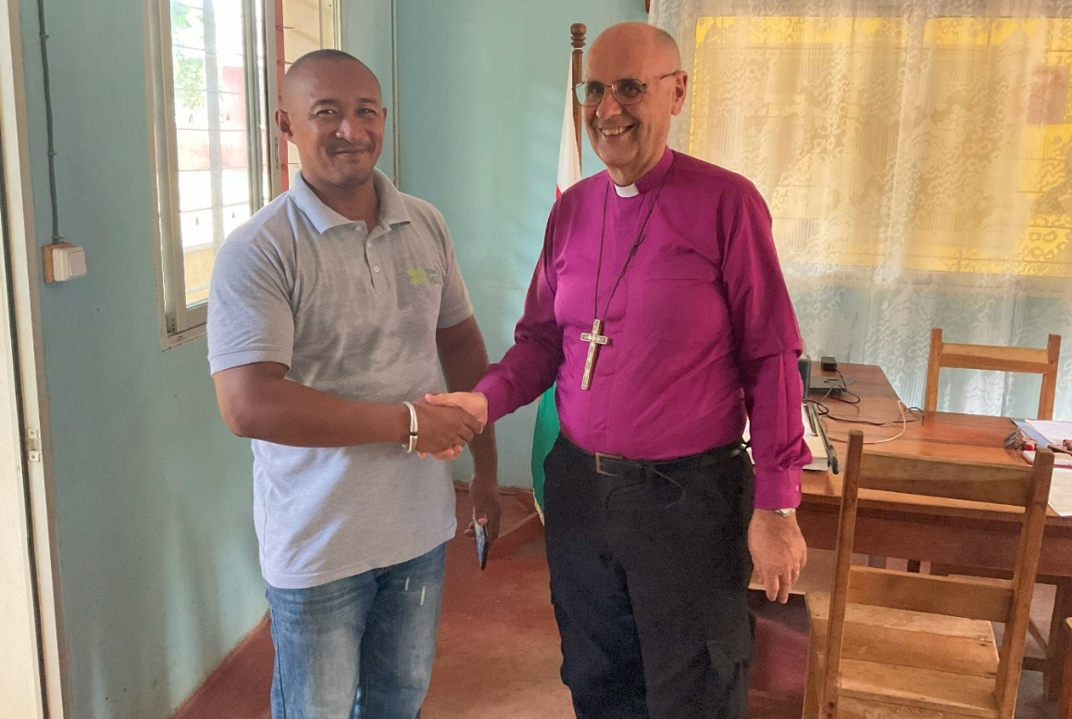
The official hand shake with the Préfet.
In spite of the smiles and handshakes and speeches of welcome, the traditional celebratory meal of a good natured looking brown ox, exchange of gifts, etc. this was overall a pretty depressing visit.
However, before I could fully follow up all that had come to light it was the pre-ordination retreat and back to Marovoay for the Ordination Service. After my previous experience there I had all my helpers on board and this service organised to the last detail. It was indeed a glorious event.
The service began with the installation of the new parish clergy, a husband and wife team. The Revd Nivo, who is also Diocesan President of the Mothers Union, to be priest in charge of the hub church of St. John, Marovoay, and her husband, the Revd Julien, to be in charge of the surrounding country churches. Tahiry was the young man being ordained. He comes from Marovoay and the ordination service was held there to facilitate the maximum number of his relations to be present as well as making the celebratory meal afterwards easier to cater for.
Tahiry’s grandparents were influential in ancestor worship and had household idols and a gift for healing. Therefore Tahiry’s Christian faith and call to ministry is a major break with family tradition. He is also the academic of our current ordinands, the only one learning Hebrew and Greek. However what was much more in evidence is his devoted love of the cathedral dean’s daughter, a medical student. She was very much to the fore looking extremely glamorous.

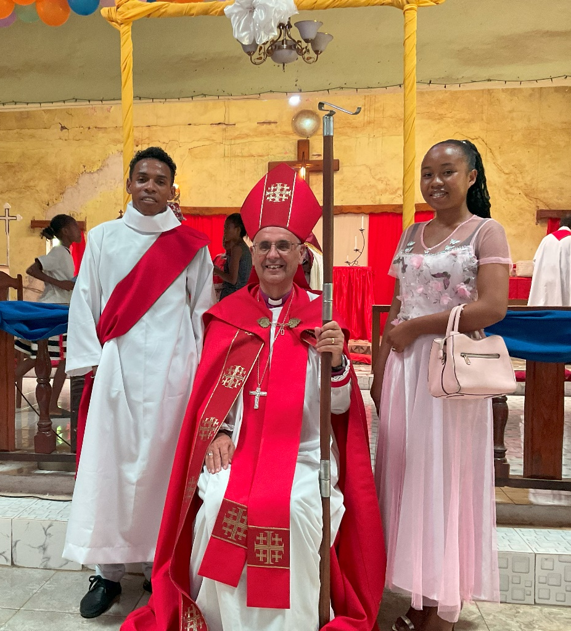
The Rev. Tahiry and Gastel, daughter of Dean Gaston.
I was asked if they were allowed to dance in Lent. Being a pathetic dancer it never occurred to me that one might give it up for Lent but here, where many involuntarily miss a meal, but almost everyone loves to dance I suppose dancing is something one might need to discipline oneself about! When I reminded them that every Sunday is a mini-Easter and thus a celebration there was great delight. The “Gospel Dance” was indeed a joy to behold with the young people perfectly together and bursting with energy. Although the Service was long it was really uplifting and energising.
I had spent only two nights at Bishop’s House in over a fortnight and I got back to find the larder and fridge empty and no gas. The rainy season continues with very frequent power cuts.
Meanwhile preparations for my Farewell service carry on but changing almost daily. The Archbishop has now decided to come from the Seychelles and, to put it mildly, this complicates things. People keep asking for photographs of Sarah and myself which is quite an embarrassment as, by the nature of things, there are a hideous number of me and none of us together!
People keep hoping that, in spite of what I have said, they are all going to have a lovely surprise when Sarah appears for the Service. The Malagasy are optimistic, sometimes unreasonably.
Once again, thank you for your support without which I am sure I couldn’t manage the current hectic activity. God Bless
+Hall
hallspeers@gmail.com

4th March 2024

