Our Mad Life 95
Paddling along
Time is running out! But Madagascar can always provide a new challenge and great experiences. Sunday, 3rd March, was in the diary for the dedication of a new church and Confirmation at Ambario in the parish of Port Bergé.
Since we are still experiencing sudden downpours which can stop traffic and play havoc with the road surface I insisted that we set off at 5.30 am on the Friday morning. There was indeed a little rain but the day cleared up and we drove along in brilliant sunshine. The Mothers’ Union worker joined us along the way. Children stand by the worst potholes and when they see a vehicle approaching throw some earth in the direction of the holes and extend their hands for a tip for their contribution to road repairs. It is believed that some of them then empty the pot hole again to maintain their source of income. The most dramatic rut/pothole was outside the town of Mampakony. It was a good five feet deep. Had it been raining and filled with mud we could not have gone through. In some places where the sea of mud covered the entire road boys were offering their services to run in front of the vehicle so we could see where the safer shallower parts were.
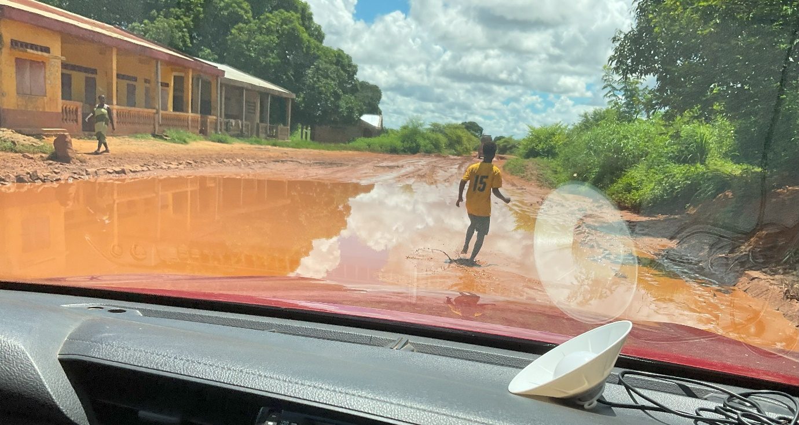
We declined an invitation to lunch when we stopped at the church school at Antanankova and arrived in Port Bergé for a very late lunch. Luckily most roadside eating places have no fixed hours for meals and often have someone standing outside shouting out the menu. Our café at Port Bergé has a chorus of young men who chant (rap?) it as soon as a taxi brousse slows down.

At 6 pm I joined the large congregation in the church for the Stations of the Cross: a very popular service on Fridays in Lent. Afterwards arrangements were made for the next morning. We were all to be ready at 7 am and set off for the Confirmation rehearsal at 11am.
I didn’t for one minute expect this timetable to work as we had people joining the party from a great distance, a sound system to be collected, etc.
At 10 am we actually left having given up on some of the people getting to Port Bergé. After a half hour drive we arrived at an isolated football pitch with a view over a vast expanse of muddy water. The archdeacon was constantly on his mobile. Here we were to embark on a flotilla of dugout canoes – except that there weren’t any! We all peered into the distance but there was no sign of anyone. Just over an hour later the first canoe appeared in the distance and so we set off down the bank. I was so intrigued by the sight I didn’t notice a large root across the path and shocked everyone by falling flat on my face. Apart from a bleeding toe and scratched knee and filthy earth covered trousers I was none the worse. From then on people insisted they held my hand in the steeper and slippery places. Poor old man! I gingerly got into the canoe remembering past difficulties doing so.
First mistake: I sat down facing in the wrong direction. With considerable difficulty and much wobbling of the canoe I got to my feet, turned round and sat down only to be told I needed to be further north. “North” helpful people repeated – but I had no idea where north or south was. To Malagasy that is like not knowing your right from your left. A lady gently pushed me in the right direction. Next on board was the MU worker. She was asked to get out immediately as she was too heavy as the canoe sank dangerously low in the water. She had put on quite a bit of weight since our last outing. I was very struck by the similarity of expertise of my pilot last week who worked out meticulously the weight on board the plane starting with the passengers and his ability to fly accurately through the cloud and the expertise of my oarsman who knew exactly how much weight the canoe could take and navigate through a thicket of reeds and then out into the featureless water. Off we went.
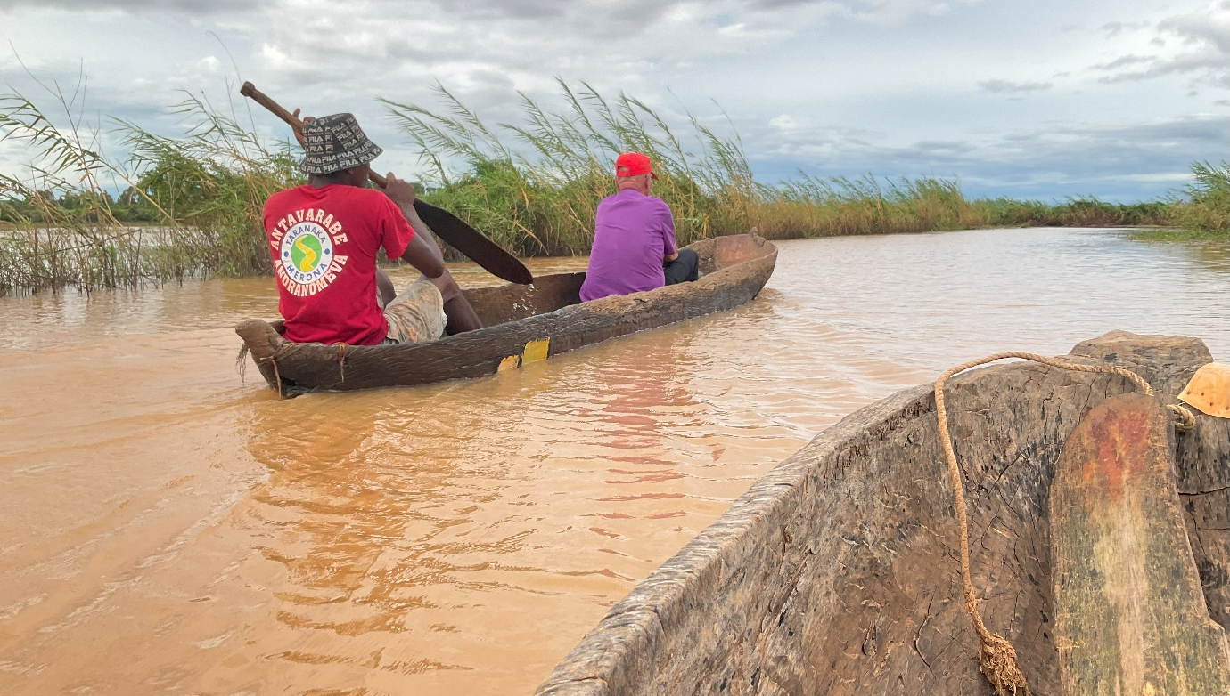
With his one paddle the oarsman steered the canoe with great accuracy. Soon we were out of the reed beds and into a wide expanse of water. It was a real ‘wow’ moment. There was almost complete silence apart from the rippling water. The many birds great and small were undisturbed by our passing and I was intensely aware of how wonderful creation is and the expertise of people who live in these watery places. One felt at one with the locals so blissfully unaware of ‘the time’. Just being alive in this calm world was great. An hour and a half of sitting absolutely still did leave my back aching.
By the time we arrived we were late for lunch and of course the rehearsal simply moved to the afternoon and then it was time to return to the canoe. Next day, Sunday, repeat performance. I left my hotel at 5.45 am but this time there was a crowd waiting to welcome the bishop off the canoe and escort me with singing and dancing to the church. We arrived to find the church full and only 15 minutes before the scheduled start of the service but I was ushered into the nearest house and a very welcome breakfast of rice, beef and coffee served. I needed it. The service started just after 9 am and finished just before 2.30pm. Never a dull moment except perhaps the bishop’s sermon.
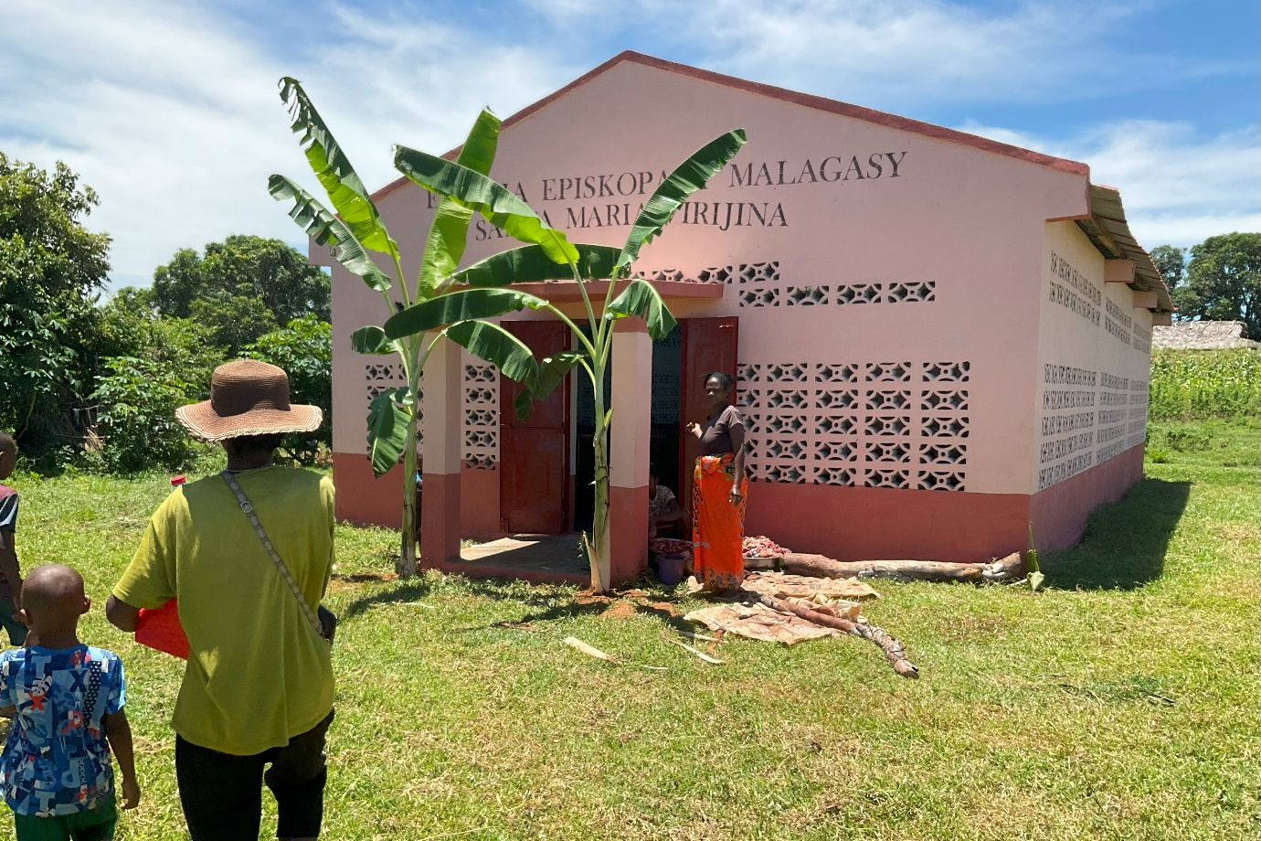
The new church of St. Mary the Virgin, Ambario
We started off with a grand procession around the exterior of the church as I blessed it at the corners and then formed up in front for the cutting of the ribbon and the bishop knocking three times on the doors. I get a childish thrill out of this ceremony as the metal tip of my crozier makes a resounding noise on the iron doors. This had been carefully rehearsed with the Dean inside ready to unbolt the doors and dramatically fling them open.
Surrounded by a host of cameras I whispered to the Archdeacon “Scissors”. He loudly repeated the command only to be told that he had them. He suddenly remembered that he had them and had left them in the church. By this time all outside had guessed the problem and there was laughter as the Archdeacon tried to communicate unsuccessfully with the Dean inside who was not going to open the door until there were three loud bangs… A happy moment of innocent farce as the Archdeacon phoned the Dean and scissors were slipped through a side door.
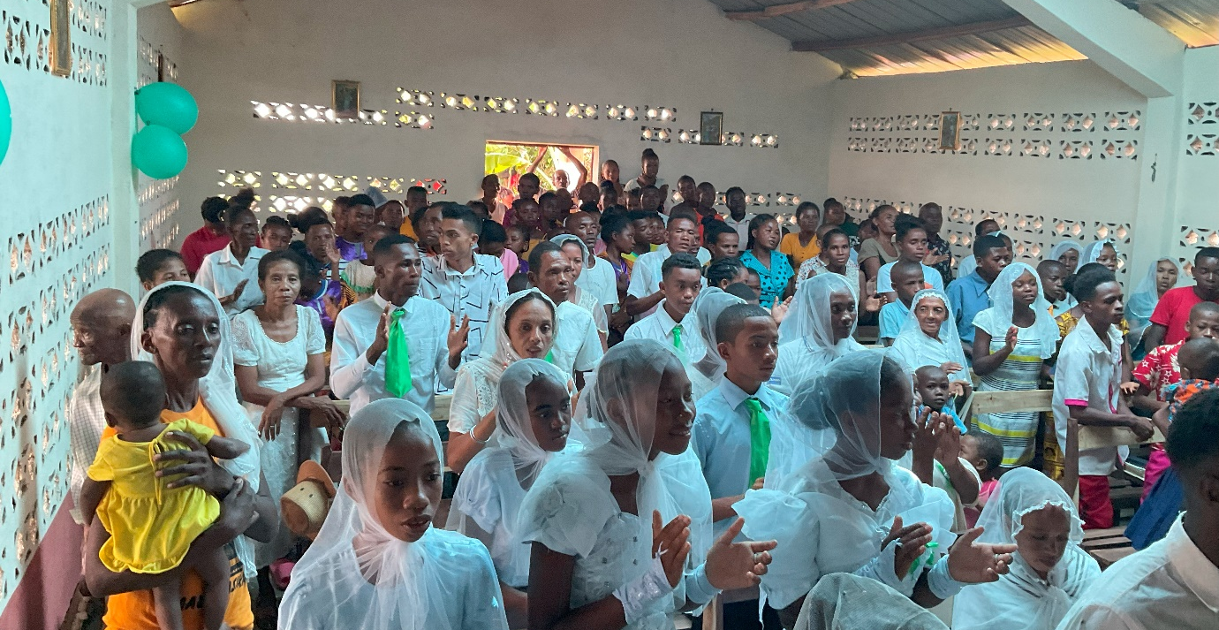
A packed church with overflow congregation enjoyed singing with, as so often, several choirs. The leader of the Antsohihy choir announced in perfect English that the next item was dedicated to the bishop and was about the love of God that unites us even when we are far away across the world. Sitting behind them I couldn’t make out a word but each verse was greeted with thunderous applause. The service ended with lively dancing which was incredible as it was well after lunchtime and I was struggling to keep smiling and clapping. I had to have a lie down before eating.
These meals consist of mammoth quantities of rice and boiled ox. No vegetables or fruit. The great pleasure is to eat until you can eat no more.
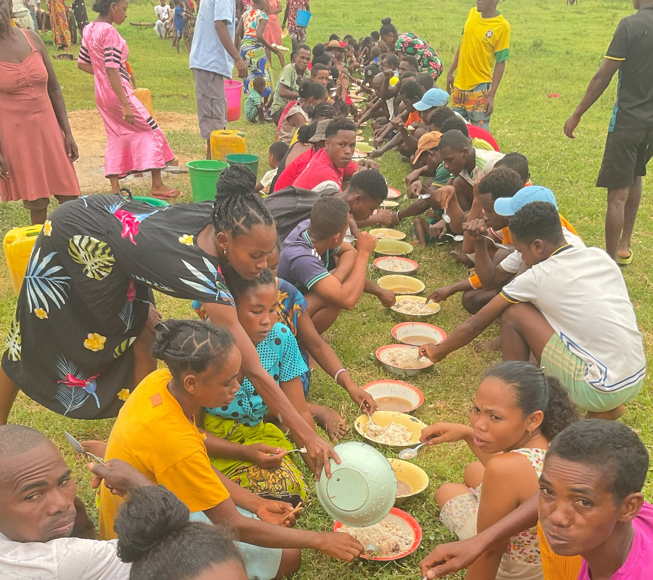
And so back to the dugout hoping to get ashore before dusk.
We calculated that if we kept going we would be back in Mahajanga about 1 am. Mercifully there was no rain but it was pitch dark before we got very far and were stopped by the police and informed it was too dangerous because of the risk of bandits for a lone vehicle to continue and we would have to wait until there were at least 5 to form a convoy. At long last we got sufficient fellow travellers to continue on our way. But where some of them turned left and headed for the capital and we turned right for Mahajanga we were again stopped by the police with the same warning.
After midnight the local Deputy/MP came along heading for Mahajanga. He had two armed guards so the police allowed us to continue behind him. As dawn broke we stopped for a rest and coffee. So much for the timetable. Everyone was kindly counselling me to have a couple of days rest to recover but I got back to find the Farewell Committee anxious to meet with me. It had been decided that the Farewell was at least a two ox event!! Could I help out to buy a second fat ox – the money was only sufficient for one fat and one thin. Sorry, No.
At the time of writing (9th March) said oxen are at the cathedral!
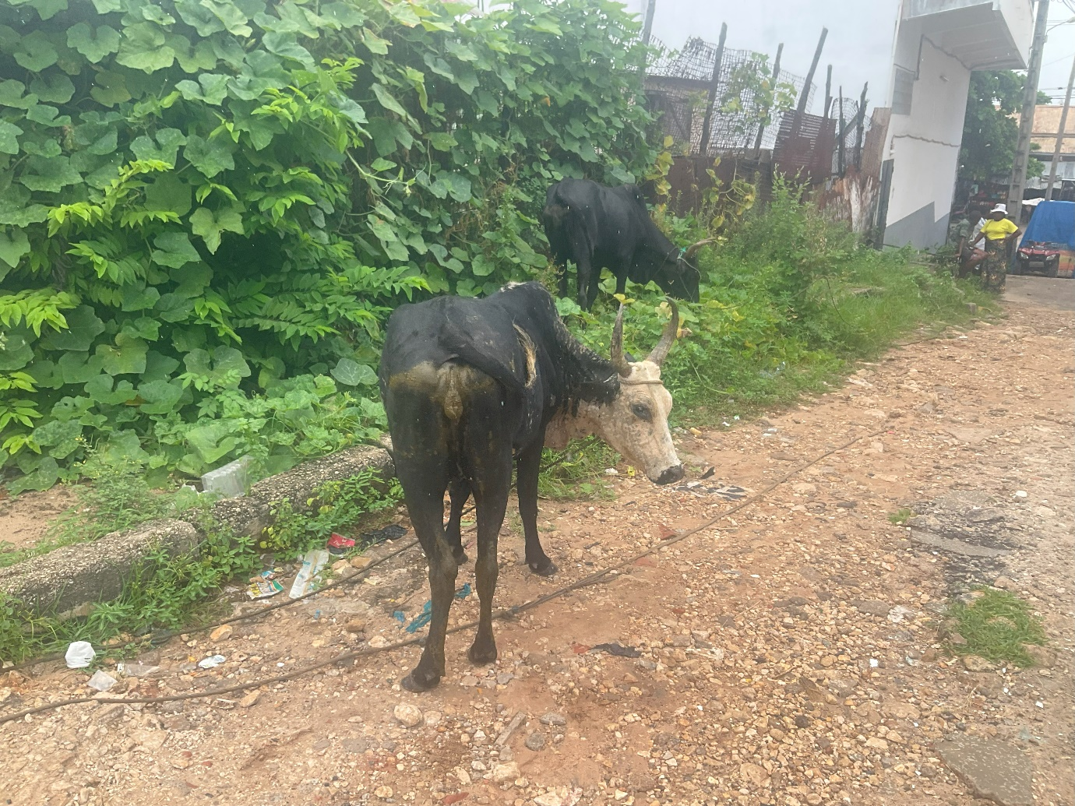
The fat ox (left) and the thin ox (right) grazing on the roadside outside Bishop’s House.
The complications of the next week I can’t bear to tell you.
Just pray that somehow, miraculously it will all happen and have a happy ending.
Love and Prayers
+Hall
hallspeers@gmail.com

9th March 2024

