Our Mad Life 96
The Grand Farewell
My last week in Mahajanga began with the Confirmation Service at St James’ in the suburbs of Mahajanga. I had met with the candidates the day before. An interesting group in their late teens and early twenties with the usual wonderful selection of names, among them young men called Platini Juvance and Lauréat Joë. Once more there was a parish lunch but this one was extra special as it was my last visit to the church and they wanted to give me my favourite: lamb cooked in a coconut sauce. I had seen the unfortunate sheep the day before. My family members had just arrived for the final farewell and so our daughter Catherine and my sister Anne were in the congregation but not our daughter Ishah who, on arrival at the church, took great delight in joining the cooking team and thus reviving her Malagasy language and making friends for life. Although people were astonished and delighted to hear Ishah speaking in Malagasy a lot of them couldn’t get it into their heads that she therefore understood the language and so she heard an interesting uninhibited flow of comments!

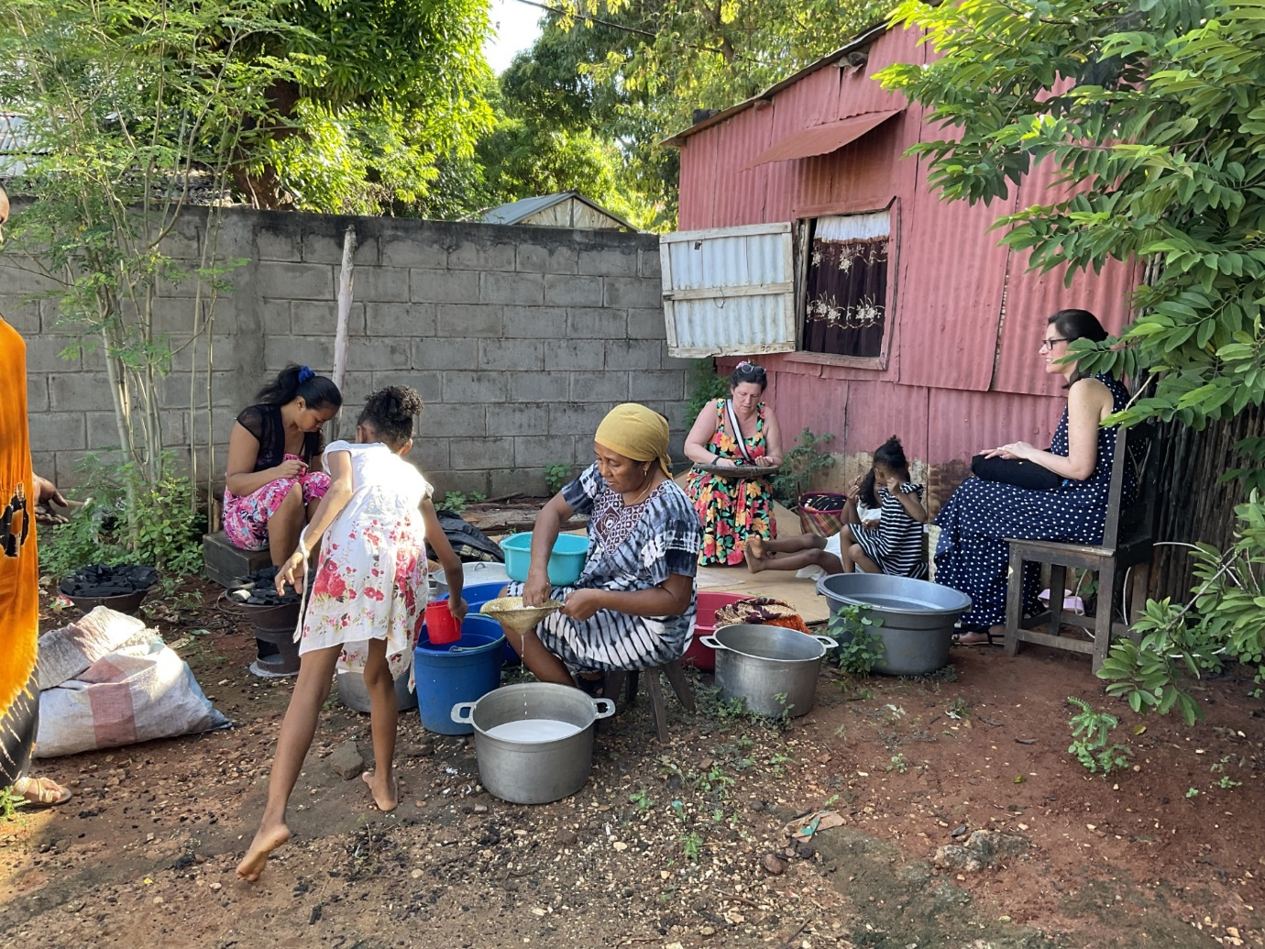
Ishah preparing rice, Mme Laurence in the foreground preparing the coconuts. Catherine on the right about to go into Church

After lunch another treat for the bishop: the Sunday school put on a show of singing and dancing. It was indeed a treat which I thoroughly enjoyed. When the younger ones danced it was unintentionally hilarious as a little girl in the front row unfailingly got her moves wrong, turning left when everyone turned right and vice versa but done with verve and a smile. As a finale I was pulled to my feet – a very awkward bishop stiffly shuffling and swaying his hips trying to mimic the moves of the other adults. This performance delights everyone – if only my sermons were so rapturously welcomed!

On the Monday 70 clergy and laity from all over the country started arriving for a “Grass roots” training course – that is how they are going to train the rural catechists/readers and evangelists. The Archbishop decided to shorten the course by starting on Wednesday instead of Monday afternoon and having evening sessions as well as morning and afternoon. This meant that those who had made travel arrangements arrived before accommodation was available and pitched up at Bishop’s House. Early on Tuesday morning I was awakened by excited chatter as they all had the prospect of a two day unexpected holiday.

Meanwhile Orders of Service had to be printed. In Madagascar a printed order of service is very unusual and has to be bought by those who can afford to – usually as a souvenir as well as something to follow the service in. Only a hundred were printed – my mistake. I wasn’t convinced that the huge numbers predicted to attend my Farewell Service would materialise given that parishioners from both the north and south of the diocese could not afford to come.
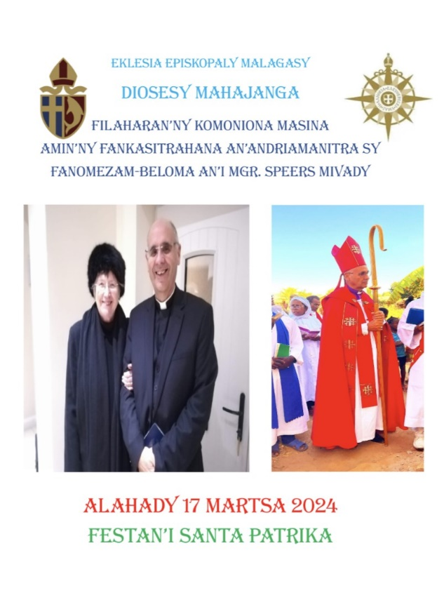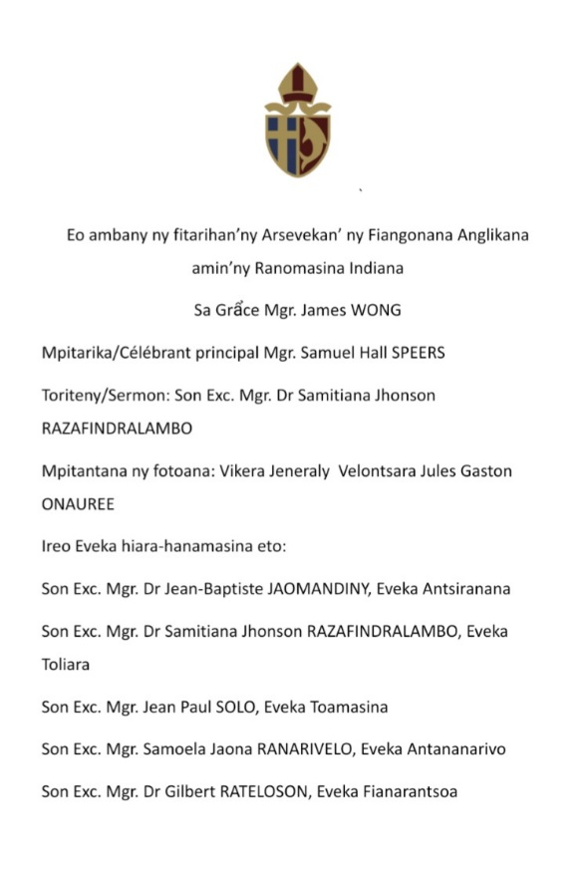
Cover and first page of the Service booklet listing participating bishops.

On Tuesday evening I had to be at the airport to welcome Archbishop James and a lovely Kenyan couple Rev Captain Ricard Mayabi and his wife, also a priest and Church Army Captain, who had come to lead the Grass Roots Training programme, and deposit them with the ever welcoming and hospitable RC Sisters of the Sacres Cœurs. Meanwhile there was my last meeting of the Diocesan Development Committee which ended with a plea that I continue to meet online with them until the appointment of the next bishop. Could I help fund a few projects? NO. I told them that my funding flow tap was being switched off on Sunday. Well, perhaps it might still drip for a while!!

The Archbishop designated his visit as a ‘pastoral visit’ and so I was requested to take him on a visit to a parish. Since the only parish that could be visited without an overnight stop was Marovoay I once more set off for there. It was hot, 38C! (over 100F). The new clergy couple there managed to get a full church to welcome him. The Archbishop spoke in French and I asked the Rev Julien to translate into Malagasy. It soon became clear that his French wasn’t as fluent as the Archbishop thinks most people in Madagascar are. I kept prompting with vocabulary and there were ripples of laughter from time to time as some in the congregation understood much better than he did and his translation parted company with what His Grace had actually said.

Thursday evening yet another welcome party at the airport when the bishops of Antananarivo, Toamasina, Toliara and Fianarantsoa and their wives arrived (thanks to our link diocese of Canterbury paying their airfares). The bishop of Antsiranana, wife and some of his family arrived by road later. All these guests turned up at the Grass Roots Training sessions for their meals which were being cooked by our MU team. These same hard working ladies were also doing a sit down meal for 150 guests on Sunday and a simultaneous buffet for the rest of the congregation, number unknown. Next to arrive were our own lovely Anglican Sisters FJKM who travelled overnight and were at Bishop’s House for breakfast on Friday morning. All very jolly but the home team was definitely showing signs of fatigue and stress.

Saturday, after the 6 am service the catechist and the cathedral servers assembled to slaughter and cut up the oxen while the wood for the cooking was being delivered to my front yard.

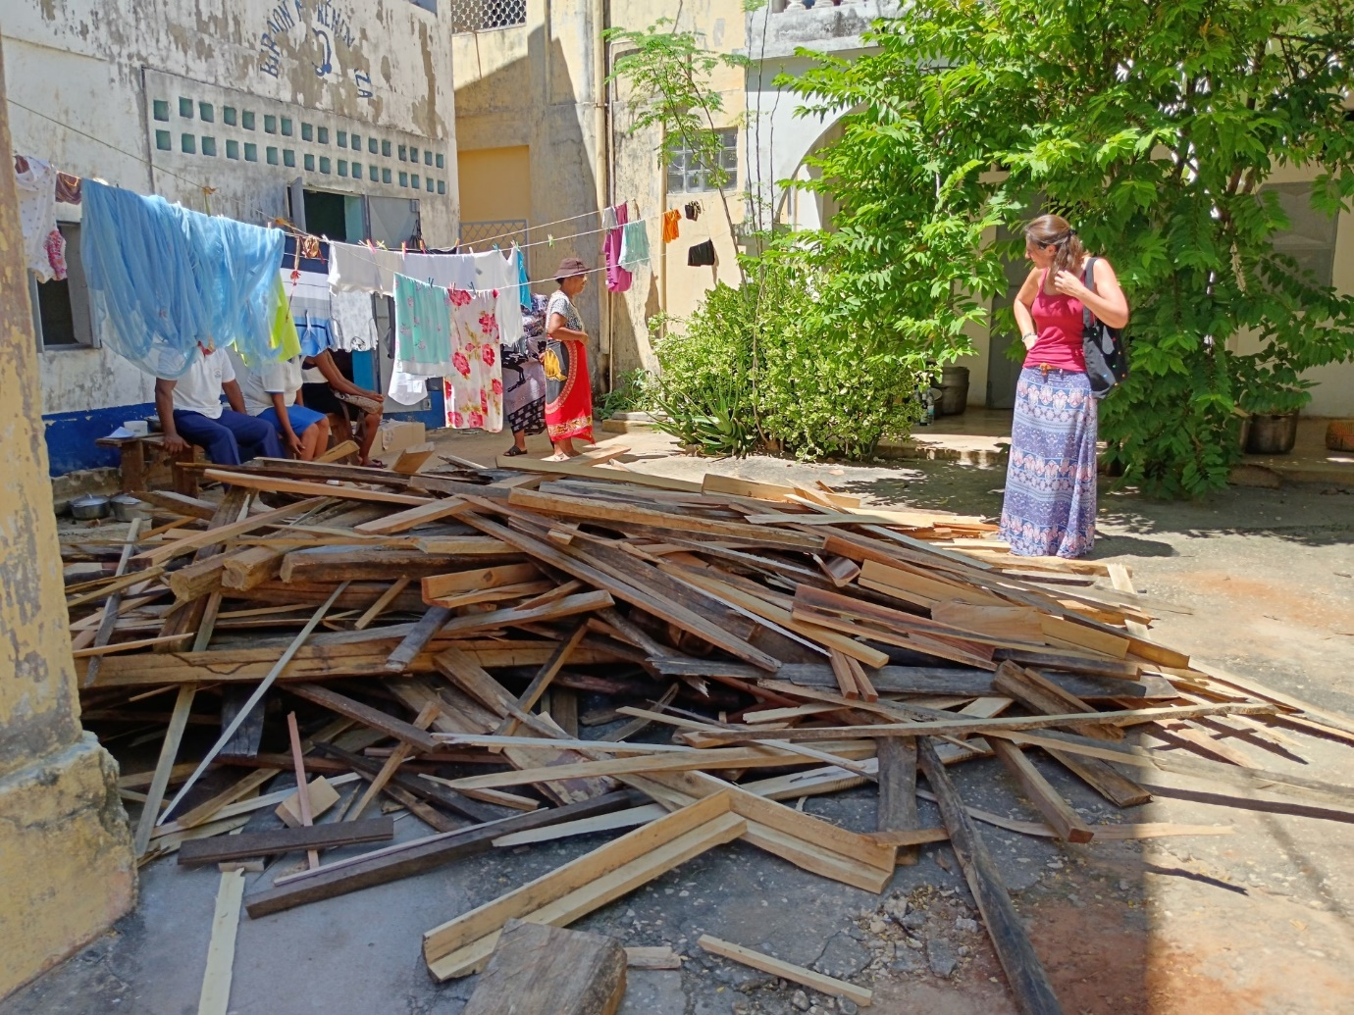
The wood to cook the rice and the two oxen

I was alarmed to hear that the fires would be lit at 4 am on Sunday which meant all involved being up well before that.

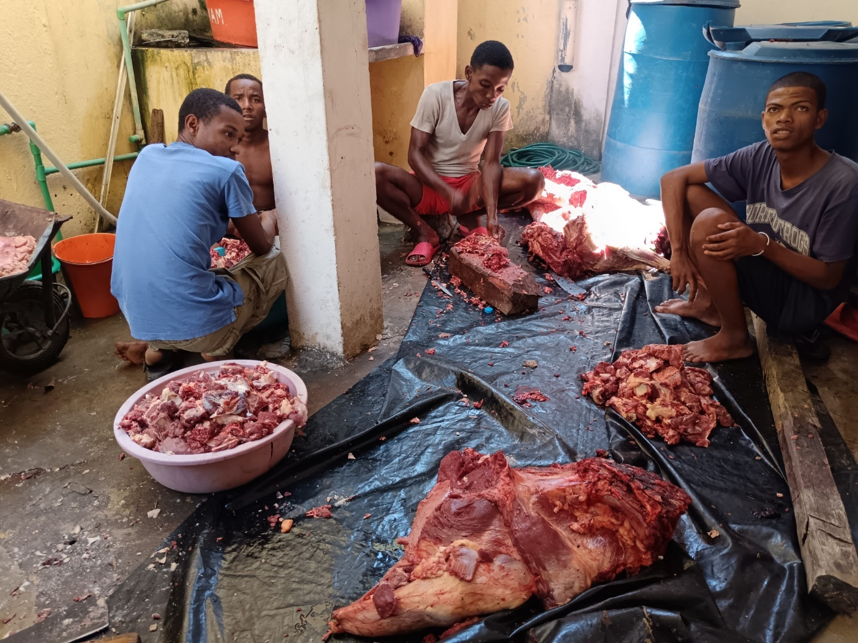
The cathedral servers hard at work chopping up the oxen in Bishop’s House wash place. Note the blue tanks of water in case of a power cut and no running water.

On Saturday afternoon there was a rehearsal and then the Archbishop announced that there would be a grand commissioning service for the Grass Roots participants at 5 pm when each bishop, dressed in cope and mitre, would commission the delegates from his own diocese. Several bishops suggested that we might do this without copes and mitres given the temperature. The Archbishop flatly refused this! A long service took place with speeches of thanks and another dinner.

At this stage I was getting seriously worried that we all, but especially myself, would be suffering from exhaustion before we even began the Sunday programme, mindful that we would be getting under way at Bishop’s House at 3.30 am!! The procession to the cathedral was to leave there at 8.30 am.

And so after a short hot night a St Patrick’s Day not to be forgotten got under way with a rather tired bishop at the centre of it all. At 8.30 am a long procession did leave the Evêché bringing traffic to a halt as we made our way to the cathedral which indeed was full with loudspeakers relaying the service to those outside. Bishop Samitiana preached a wonderful sermon, choirs sang, the teenage “Gospel Group” danced brilliantly and of course there were the inevitable speeches although the bit the congregation enjoyed most was the clergy of Mahajanga and their wives dancing. As I listened to the speeches it felt rather unreal, as if I were present for the eulogies at my own funeral – nearly all being in the past tense.

But what really took me by surprise was the sudden forming of a very long queue of people coming forward with presents. I had made it clear that I didn’t want gifts for the very practical reason that I couldn’t take them home on the plane. It was incredible to see the lengths so many had gone to craft light weight items. I was astounded by them, not least a carved statuette of myself which was far from light weight!
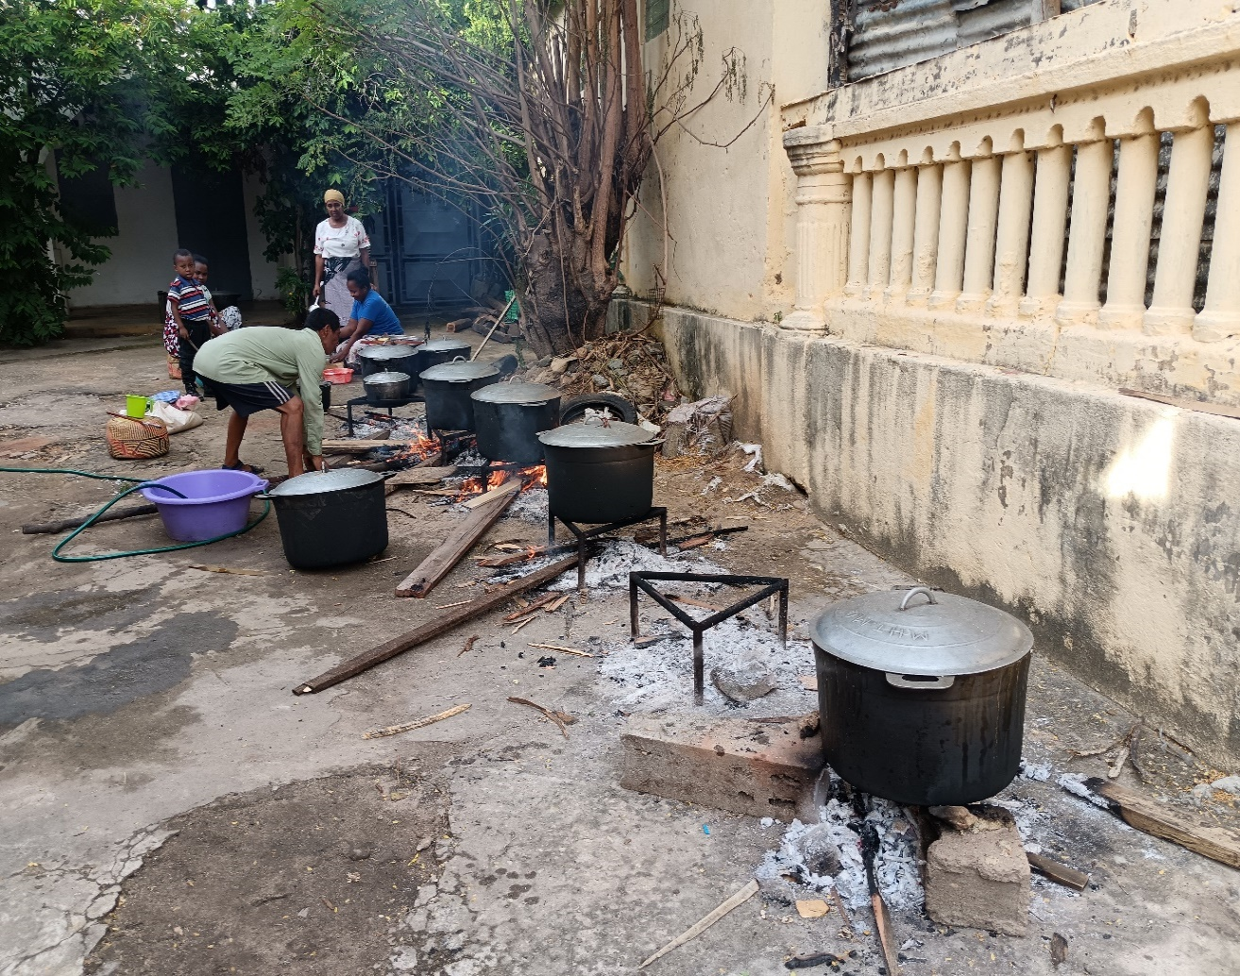
The Sunday lunch almost ready and that great pile of wood has been completely used up!

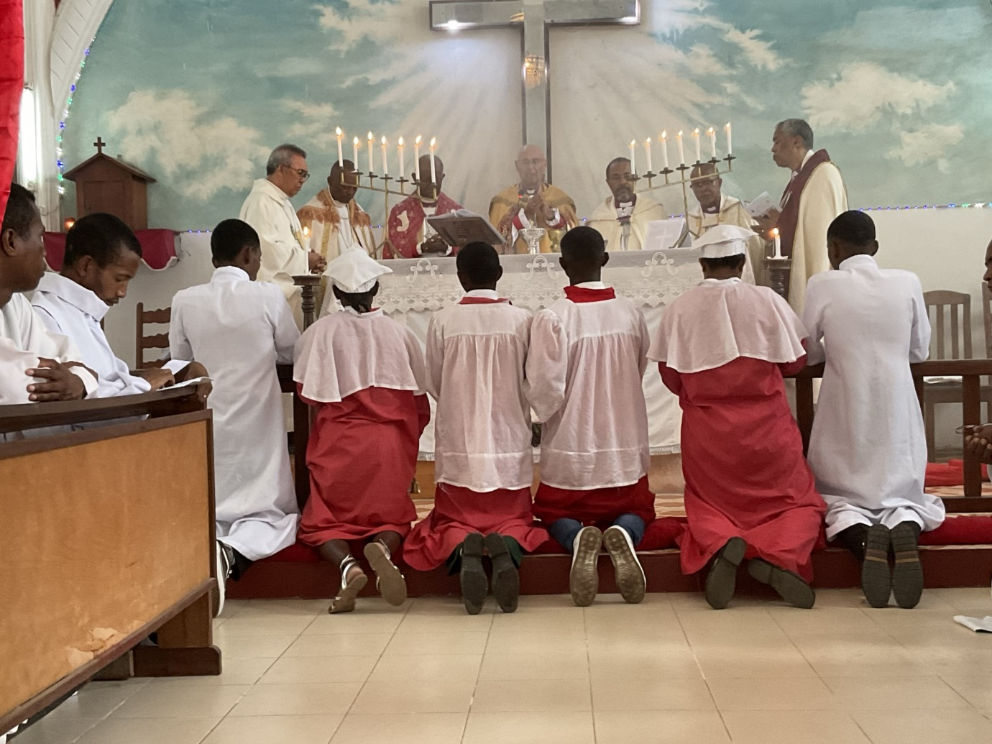
Above: Seven bishops concelebrate Below: A scroll from the diocese of Antananarivo
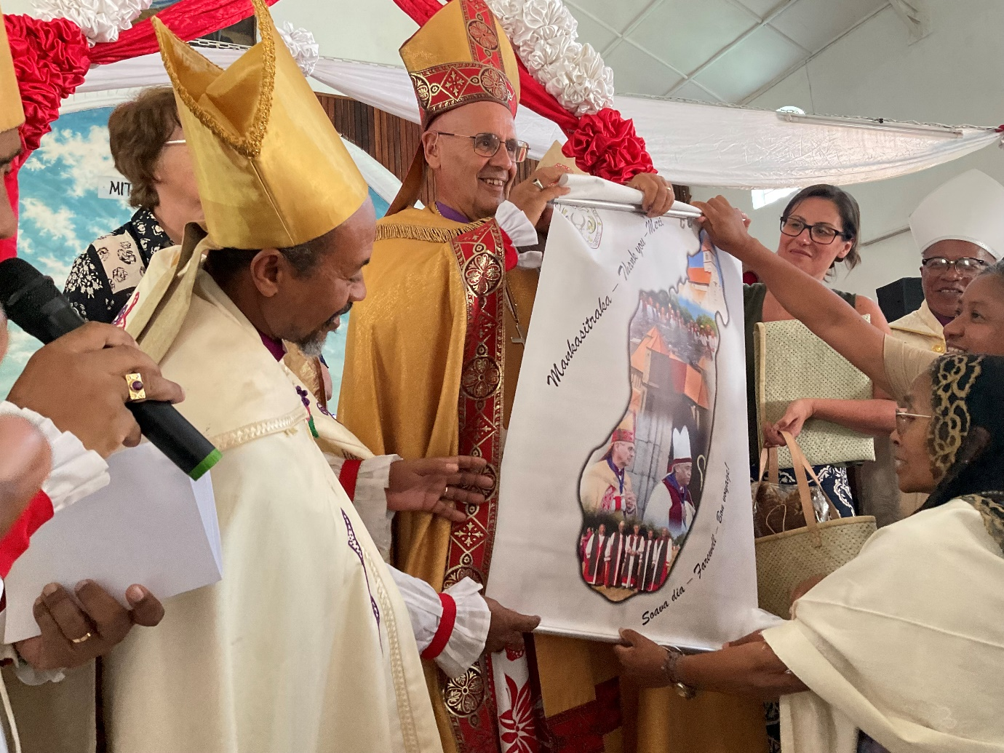

After all that a quick trip back to the house to change out of my soaking clothes and set off for the lunch. I had intended to return to the cathedral to circulate with the congregation who were eating there, not having received invitations to the VIP luncheon, but I was too tired to do anything more than the essential and so set off to the Police headquarters where the selected 150 were already waiting.
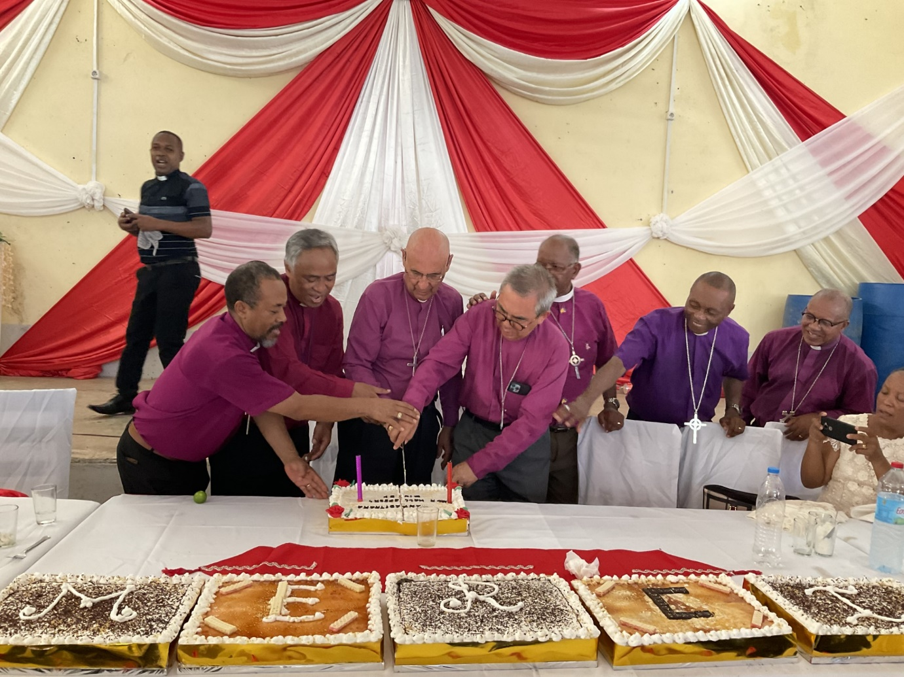
Bishops: Toamasina, Antananarivo, self, Archbishop (Seychelles) Toliara, Antsiranana and Fianarantsoa.

It was not long before the dancing began but this was interrupted by the cake cutting.
After that the dancing really got going as if people were having the time of their lives. My daughters were dragged onto the stage to join in. At 5 pm we left and the rest of the day remains a blur in my memory.

What a celebration and what an incredible amount of work and planning went into it.
I can only thank God for having had the privilege to serve the diocese of Mahajanga and thank all of you who supported me so generously.

God bless you.
+Hall

P.S. The “tap drips” as I try to complete a Church and a School.

hallspeers@gmail.com

12th April 2024

