St. Paul, Wokingham, St Nicholas, Emmbrook and Woosehill Church

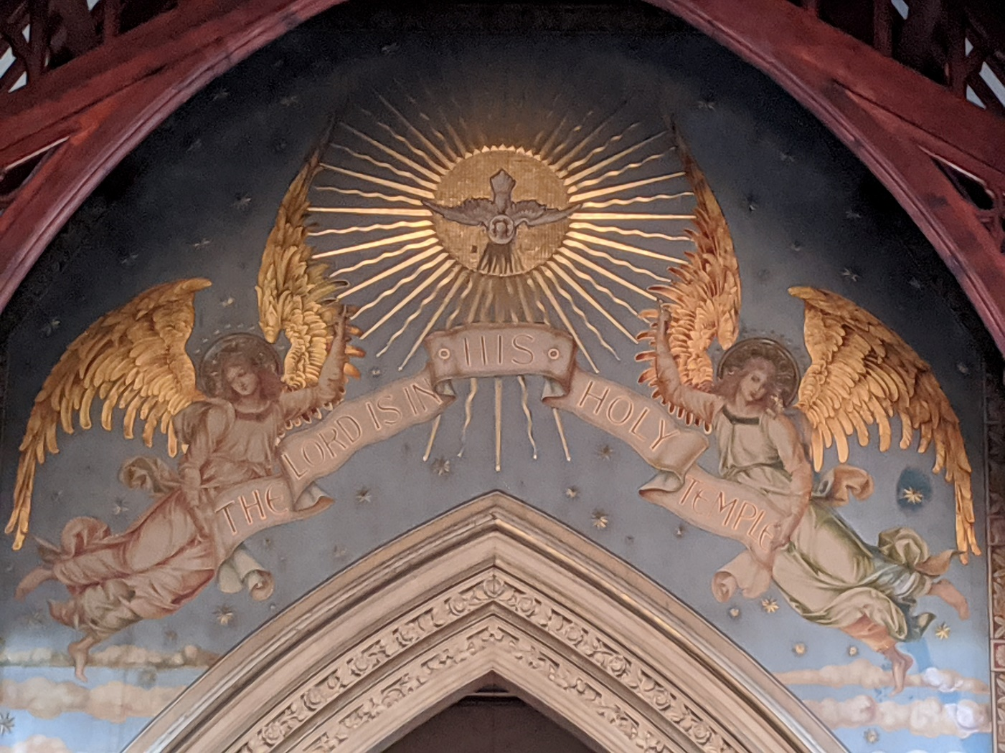

Parish Eucharist for the final Sunday of Richard Lamey
as Rector of the Parish

Sunday the 14th of July 2024

During the Eucharist we
- gather together as one family, made up of 3 churches and beyond
- say sorry for our sins and receive God’s forgiveness
- proclaim and respond to the word of God
- remember before God the Church and the world
- share in the peace of Christ
- pray the Eucharistic Prayer and receive communion
- depart with the blessing of God, to live lives to his glory.

Welcome to this special service in the life of the parish as we gather together from all three churches to give thanks for all that God has done in our shared life, and to embrace all that God has in store for us in the years to come- as he continues to call and inspire and draw us into the world to help build the coming Kingdom of love. Welcome whether you are here in person or present via the livestream.

Where it is customary to sit or stand during worship, this is noted in the order of service. If it helps you to worship God, please stand/ sit/ kneel for these parts of the service - if standing is hard or risky then please remain seated.

Communion can be received either at the chancel step or in your pew. Please tell the priest if you need a gluten-free wafer. If you would prefer to receive a prayer of blessing please come forward with everyone else and keep your head bowed. If you would like to receive communion or a blessing in the pew, please tell a welcomer.

The Gathering

Opening Hymn
Lord of all hopefulness, Lord of all joy,
whose trust ever childlike, no cares could destroy,
be there at our waking, and give us, we pray,
your bliss in our hearts, Lord, at the break of the day.

Lord of all eagerness, Lord of all faith,
whose strong hands were skilled at the plane and the lathe,
be there at our labours, and give us, we pray,
your strength in our hearts, Lord, at the noon of the day.

Lord, of all kindliness, Lord of all grace,
your hands swift to welcome, your arms to embrace,
be there at our homing, and give us, we pray,
your love in our hearts, Lord, at the eve of the day.

Lord of all gentleness, Lord of all calm,
whose voice is contentment, whose presence is balm,
be there at our sleeping, and give us, we pray,
your peace in our hearts, Lord, at the end of the day.

In the name of the Father, and of the Son,
and of the Holy Spirit. Amen.

Grace, mercy and peace from God our Father
and the Lord Jesus Christ be with you:
and also with you.

We sit as the Rector welcomes us and introduces the service.

Almighty God, to whom all hearts are open,
all desires known, and from whom no secrets are hidden:
cleanse the thoughts of our hearts
by the inspiration of your Holy Spirit,
that we may perfectly love you
and worthily magnify your holy name;
through Christ our Lord. Amen.

Prayers of Penitence
Jesus said: Before you offer your gift, go and be reconciled.
As brothers and sisters in God’s family,
we come together to ask our Father for forgiveness.
Almighty God, our heavenly Father,
we have sinned against you, through our own fault,
in thought and word and deed,
and in what we have left undone.
We are heartily sorry, and repent of all our sins.
For your Son our Lord Jesus Christ’s sake,
forgive us all that is past;
and grant that we may serve you in newness of life
to the glory of your name. Amen.

(We sing)
Lord, have mercy: Lord, have mercy.
Christ, have mercy: Christ, have mercy.
Lord, have mercy: Lord, have mercy.

The Absolution God’s promise of forgiveness
Almighty God, who forgives all who truly repent,
have mercy on you,
+ pardon and deliver you from all your sins,
confirm and strengthen you in all goodness,
and keep you in life eternal;
through Jesus Christ our Lord. Amen.

Gloria in Excelsis (We stand)
A song of praise to God for his wonderful goodness

Glory to God, Glory to God,
Glory to God in the Highest,

Glory to God in the Highest,
and peace to his people on earth.
Lord God, heavenly King, Almighty God and Father,
We worship you, we give you thanks,
we praise you for your glory.

Glory to God, Glory to God,
Glory to God in the Highest.

Lord Jesus Christ, only Son of the Father.
Lord God, Lamb of God,
you take away the sin of the world;
have mercy on us;
you are seated at the right hand of the Father:
receive our prayer.

Glory to God, Glory to God,
Glory to God in the Highest.

For you alone are the Holy One, you alone are the Lord,
you alone are the most high, Jesus Christ,
with the Holy Spirit, in the Glory of God the Father.

Glory to God, Glory to God,
Glory to God in the Highest.

The Collect
A prayer which sets the theme for the service
The Lord be with you: and also with you.
Let us pray.

Lord of all power and might,
the author and giver of all good things:
graft in our hearts the love of your name,
increase in us true religion,
nourish us with all goodness,
and of your great mercy keep us in the same;
through Jesus Christ your Son our Lord,
who is alive and reigns with you,
in the unity of the Holy Spirit,
one God, now and for ever. Amen.

There is no J-Club this morning- instead, colouring and activities are available in the Children’s Chapel at the back of Church. Children are very welcome to wander around and to make sure they get a good view by coming to the front!

The Liturgy of the Word

A Reading from the Bible (We sit)
1 Kings 19.1-13 (read by Alison Lewis, from Woosehill)
This is the word of the Lord. Thanks be to God.

Gradual Hymn
See, what a morning, gloriously bright,
with the dawning of hope in Jerusalem;
folded the grave-clothes, tomb filled with light,
as the angels announce Christ is risen!
See God’s salvation plan,
wrought in love, borne in pain, paid in sacrifice,
fulfilled in Christ, the man, for he lives,
Christ is risen from the dead!

See Mary weeping, ‘Where is he laid?’
as in sorrow she turns from the empty tomb;
hears a voice speaking, calling her name;
it’s the Master, the Lord raised to life again!
The voice that spans the years,
speaking life, stirring hope, bringing peace to us,
will sound till he appears, for he lives,
Christ is risen from the dead!

One with the Father, Ancient of Days,
through the Spirit who clothes faith with confidence,
honour and blessing, glory and praise
to the King crown’d with power and authority!
And we are raised with him,
death is dead, love has won, Christ has conquered;
and we shall reign with him, for he lives,
Christ is risen from the dead!

The Gospel a reading from Jesus’ life
We stand and turn to face the Gospel as it is brought into the midst
of the people, representing Christ’s presence with his people.
The Lord be with you: and also with you.
Hear the Gospel of our Lord Jesus Christ according to Mark (Ch 5).
Glory to you, O Lord.

At the end of the Gospel reading:
This is the Gospel of the Lord. Praise to you, O Christ.

The Sermon (We sit)

The Creed (We stand) We state what we believe
We believe in one God, the Father, the Almighty,
maker of heaven and earth, of all that is,
seen and unseen.

We believe in one Lord, Jesus Christ,
the only Son of God,
eternally begotten of the Father,
God from God, Light from Light,
true God from true God, begotten not made,
of one being with the Father;
through him all things were made.
For us and for our salvation he came down from heaven,
was incarnate from the Holy Spirit and the Virgin Mary
and was made man.
For our sake he was crucified under Pontius Pilate;
he suffered death and was buried.
On the third day he rose again
in accordance with the Scriptures;
he ascended into heaven
and is seated at the right hand of the Father.
He will come again in glory to judge the living and the dead, and his kingdom will have no end.

We believe in the Holy Spirit,
the Lord, the giver of life,
who proceeds from the Father and the Son,
who with the Father and the Son
is worshipped and glorified,
who has spoken through the prophets.

We believe in one holy catholic and apostolic Church.
We acknowledge one baptism for the forgiveness of sins,
We look for the resurrection of the dead,
and the life of the world to come. Amen. (Nicene Creed)

The Prayers of Intercession
(Led by Lynne Judge from St Nicholas’, Emmbrook)
At the end of each section, a response may be used:
Lord, in your mercy: hear our prayer.

The prayers may conclude with:
Merciful Father, accept these prayers
for the sake of your Son, our Saviour, Jesus Christ. Amen.

The Liturgy of the Sacrament

The Peace of Christ (We stand)
Let love be genuine. Never pay back evil for evil.
As far as it lies with you, live at peace with everyone.
The peace of the Lord be always with you: and also with you.

We offer Christ’s peace to one another, remembering those who are also part of this service in their own homes. Gifts are brought from God’s people to God’s altar.

Offertory Hymn
Alleluia, sing to Jesus!
his the sceptre, his the throne;
alleluia, his the triumph,
his the victory alone.
Hark! the songs of peaceful Zion
thunder like a mighty flood:
'Jesus, out of every nation,
hath redeemed us by his blood.
Alleluia, not as orphans
are we left in sorrow now;
alleluia, he is near us,
faith believes, nor questions how.
Though the cloud from sight received him
when the forty days were o'er,
shall our hearts forget his promise,
'I am with you evermore'?
Alleluia, bread of angels,
here on earth our food, our stay;
alleluia, here the sinful
flee to you from day to day.
Intercessor, friend of sinners,
earth's redeemer, plead for me,
where the songs of all the sinless
sweep across the crystal sea.
Alleluia, King eternal,
thee the Lord of Lords we own;
alleluia, born of Mary,
earth thy footstool, heaven thy throne.
Thou within the veil hast entered,
robed in flesh, our great high priest,
thou on earth both priest and victim
in the eucharistic feast.
The Preparation of the Gifts
Blessed be God, who feeds the hungry,
who raises the poor, who fills our praise.
Blessed be God for ever.

Pray, my brothers and sisters, that our sacrifice
may be acceptable to God the Almighty Father.
May the Lord accept the sacrifice
at your hands, for the praise and glory
of his Name, for our good
and the good of all his Church.

Be present, be present, Lord Jesus Christ, our risen high priest:
and make yourself known in the breaking of the bread.

The Eucharistic Prayer
(We remain standing if we can stand comfortably – otherwise, we sit)
The Lord be with you and also with you.
Lift up your hearts.
We lift them to the Lord.
Let us give thanks to the Lord our God.
It is right to give thanks and praise.

It is always right to give you thanks, God our Creator,
loving and faithful, holy and strong.
You made us and the whole universe and filled your world with life.
Holy, Holy, Holy.

You sent your Son to live among us, Jesus our Saviour, Mary’s child.
He suffered on the cross; he died to save us from our sins;
he rose in glory from the dead.
Holy, Holy, Holy.

You send your Spirit to bring new life to the world,
to fill us with hope and life and light and love,
our constant companion, inspiration and friend
through all of the changes and chances of this world,
and so we join the angels to celebrate and sing:

Holy, holy, holy Lord, God of power and might,
heaven and earth are full of your glory.
Hosanna in the highest.
Blessed is he who comes in the name of the Lord.
Hosanna in the highest.

Father, on the night before he died,
Jesus shared a meal with his friends.
He took the bread, and thanked you.

He broke it, and gave it to them, saying:
Take and eat; this is my body, given for you.
Do this to remember me.

After the meal, Jesus took the cup of wine.
He thanked you, and gave it to them, saying:
Drink this, all of you. This is my blood,
the new promise of God’s unfailing love.
Do this to remember me.

Jesus Christ has died. Jesus Christ has died.
Jesus Christ is risen. Jesus Christ is risen.
Jesus Christ will come again. Jesus Christ will come again.

Father, as we bring this bread and wine,
and remember his death and resurrection,
send your Holy Spirit,
that we who share these gifts
may be fed by Christ’s body and his blood.
Amen, Amen, Amen.

Pour your Spirit on us
that we may love one another,
as we work for the healing of the earth,
and share the good news of Jesus,
as we wait for his coming in glory
Amen, Amen, Amen.

For honour and praise belong to you, Father,
with Jesus your Son, and the Holy Spirit:
one God, for ever and ever.
Amen, Amen, Amen.

The Lord’s Prayer (We sit)
Our Father, who art in heaven,
hallowed be thy name.
Thy kingdom come, thy will be done,
on earth as it is in heaven.
Give us this day our daily bread.
And forgive us our trespasses,
as we forgive those who trespass against us.
And lead us not into temptation,
but deliver us from evil.
For thine is the kingdom,
the power and the glory,
for ever and ever. Amen.

The Fraction We break the bread to share it
We break this bread to share in the body of Christ.
Though we are many, we are one body
because we all share in one bread.

Agnus Dei (Lamb of God) (We sing)
Lamb of God, you take away the sin of the world,
have mercy on us.
Lamb of God, you take away the sin of the world,
have mercy on us.
Lamb of God, you take away the sin of the world,
grant us peace.

Jesus is the Lamb of God who takes away the sin of the world.
Blessed are those who are called to his supper.
Lord, I am not worthy to receive you
but only say the word, and I shall be healed.

Christ is in our midst. He is and always will be.

The choir sing two anthems during communion: “I would be true” by Philip Stopford and “Greater love” by John Ireland.

“I would be true” was written by Philip for Becca and Richard’s wedding in 2001, where he also conducted it. This is (probably) the first time it has been performed since then. The words were written by Howard A. Walter in 1906:

“I would be true, for there are those who trust me;
I would be pure, for there are those who care;
I would be strong, for there is much to suffer;
I would be brave, for there is much to dare.
I would be friend of all—the foe, the friendless;
I would be giving, and forget the gift;
I would be humble, for I know my weakness;
I would look up, and laugh, and love, and live.”
“Greater love” is a collection of Biblical texts around love and Christ’s call that we be loving as he is loving to us.

Everyone who has been baptised is welcome to receive communion here today. Please feel free to receive only the wafer if you would prefer not to receive the chalice, or if you are feeling unwell.

Post-Communion Prayer (We remain seated)
We thank God for his love, revealed in this feast
God of our pilgrimage,
you have led us to the living water:
refresh and sustain us
as we go forward on our journey,
in the name of Jesus Christ our Lord. Amen.

Almighty God, we thank you for feeding us
with the body and blood of your Son Jesus Christ.
Through him we offer you our souls and bodies
to be a living sacrifice.
Send us out in the power of your Spirit
to live and work to your praise and glory. Amen.

Notices, Banns of Marriage and Thanks

The Dismissal

The Blessing (We stand)
We receive the promise of God’s presence with us always
May you know always the faithfulness of God the Father,
unending care, unerringly true. Amen.
May you dwell always in the everlasting love of Christ our Lord,
God with you, God for you. Amen.
May you delight in the steadfast encouragement of the Holy Spirit, arrowing like a kingfisher into your heart. Amen.
And the blessing of God Almighty,
the Father, the Son and the Holy Spirit,
rest upon you and remain with you
through all of the changes and chances that come, and always. Amen.

Recessional Hymn
I heard the voice of Jesus say,
“Come unto me and rest;
Lay down thou weary one, lay down
Thy head upon my breast.”
I came to Jesus as I was,
Weary, and worn, and sad;
I found in him a resting-place,
And he has made me glad.
I heard the voice of Jesus say,
“Behold, I freely give
The living water, thirsty one
Stoop down, and drink, and live.”
I came to Jesus, and I drank
Of that life-giving stream;
My thirst was quenched, my soul revived,
And now I live in him.
I heard the voice of Jesus say,
“I am this dark world’s light;
Look unto me, thy morn shall rise,
And all thy day be bright.”
I looked to Jesus, and I found
In him my star, my sun;
And in that light of life I’ll walk
Till travelling days are done.

As the procession moves to the west end of Church,
we all turn to face the door, and the world.

St Paul writes: “I am convinced that neither death, nor life, nor angels, nor rulers, nor things present, nor things to come, nor powers, nor height, nor depth, nor anything else in all creation will be able to separate us from the love of God in Christ Jesus our Lord.”

Go in the sure knowledge and the deep truth of Christ’s love,
because the world is too precious and too fragile
for anything but courage and kindness and peace and love.
Thankful for all that God has done for us, and confident of God’s future, let us all go in peace to love and serve the Lord.
In the name of Christ. Amen.

An organ voluntary is usually played as the end of our worship. You are warmly invited to join us for refreshments in the Parish Rooms after the service. If you are here for the first time, or still feel new, or have any questions at all, please talk to a member of the clergy or a Warden so we can meet you properly.

Please take a weekly Pews News home with you today so you know what’s happening in the life of the parish and what you can be part of. You can get regular updates and sign up to our weekly ‘Bertie’ email on the parish website: www.spauls.co.uk.

This service includes material from Common Worship: Services and Prayers for the Church of England, which is copyright the Archbishops’ Council 2000. CCL Licence 54378.

A final word of thanks and hope from the Rector

It has been an amazing adventure since we came to the parish in November 2012- a new parish of three Churches together. It has been an absolute privilege to be the Rector of this community and these Churches. Thank you for trusting me and supporting me. Thank you for your care of us as a family and for your care for me personally.
At the end of any priest’s time in post the key question is “Am I leaving these churches in a better place than they were?” and the answer is absolutely and confidently and wonderfully yes. There is a fantastic foundation here for future ministry and new possibilities. And it has been fun!

It is time for a new leader and priest to come in and enjoy the challenges and delights of ministry here. I leave, knowing that God is calling me on to a new adventure where I can deploy and explore more widely the things I’ve learnt and developed here. And I leave knowing that there are excellent leaders in place across the parish who will ensure that we continue to move forward, walking carefully and joyfully together. And I leave knowing that God is already at work preparing the right person to come here as the 14th Rector of the parish (and the second in this formulation). And I leave, knowing that God is always true, always faithful and always moving ahead of us, elegant and caring, longing for us to catch up, to join in with the divine dance of love.

Dag Hammerskjold prayed: “For all that has been, thanks. For all that is to come, yes.”

May that be our prayer too, spoken with heartfelt gratitude, rooted confidence and lasting hope.

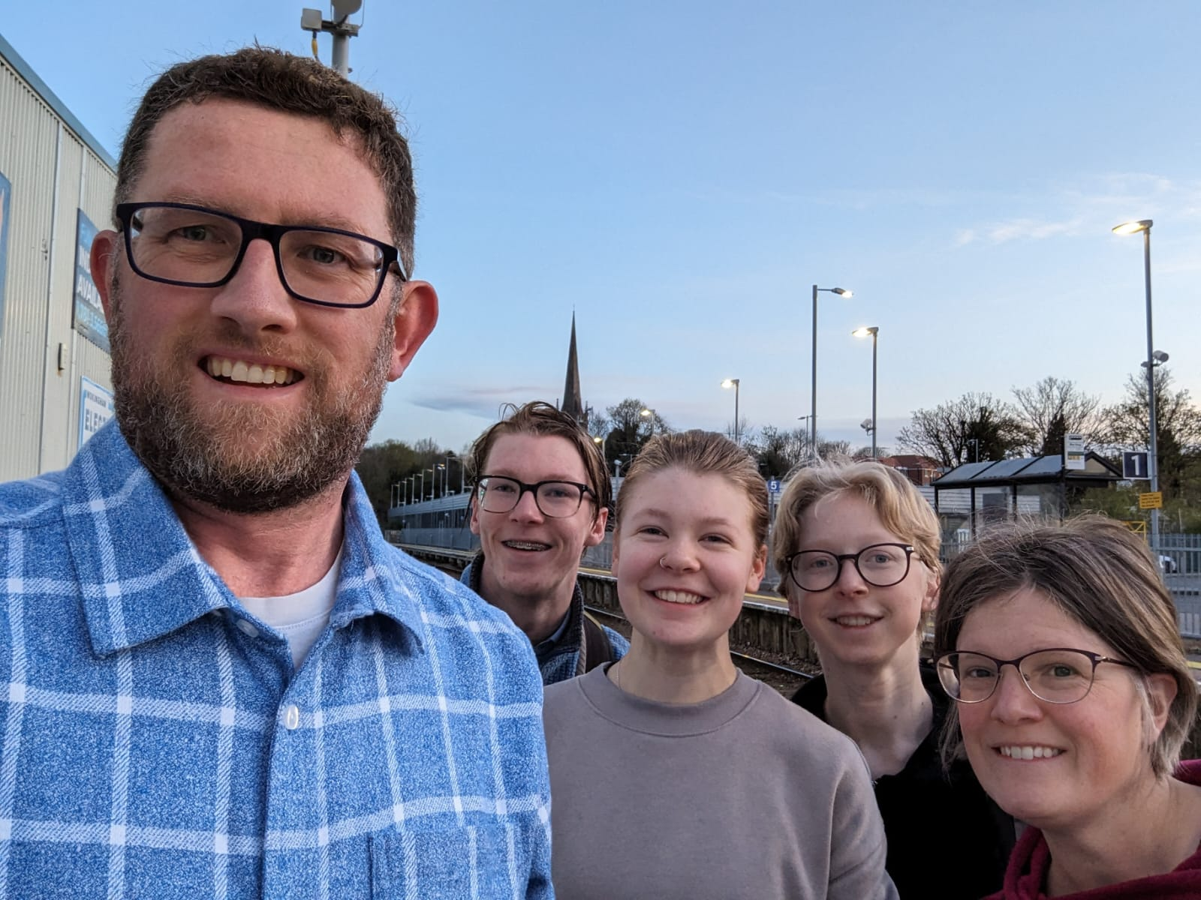

White Gift Aid envelopes are available in each pew for visitors.
If you’re a UK tax payer we can reclaim the tax on the amount you donate, but please remember to fill in your name and address on the envelope. Our QR code can be used for making donations, with the option of Gift Aid. Your generosity allows us to continue to serve the community we are part of. Thank you.

