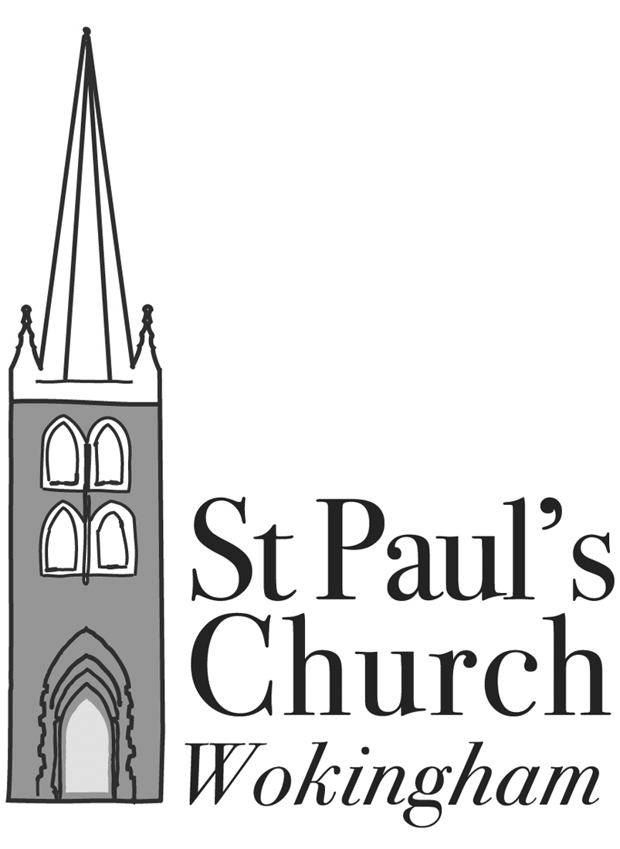
ST PAUL’S, WOKINGHAM

WITH ST NICHOLAS’, EMMBROOK

Annual Meeting of Parishioners
to be held in the Parish Rooms at 5.00 p.m. on Sunday 26 April 2026

AGENDA

Apologies for absence

Acceptance of Minutes of Meeting held on 27 April 2025 Attached

Election of Churchwardens

Any other business – to be notified to the Secretary by the Sunday prior to the meeting (19 April 2026)

Annual Parochial Church Meeting
to be held on Sunday 26 April 2026
AGENDA
- Apologies for absence
- Acceptance of Minutes of meeting held on 27 April 2025 Attached
- Matters arising from the Minutes
- Changes in the Electoral Roll since the last annual meeting Reports
- Election of Deanery Synod Reps
- Election of Parochial Church Councillors
REPORTS AND OVERVIEW
- Treasurer’s Report and Presentation of Financial Statements for 2025 Separate booklet
- Appointment of Independent Examiner
- Report from the Rector, Fr Sam Tanna-Korn
- Report from Deanery Synod Reports
- Churchwardens’ report on the fabric, goods and ornaments of the church Reports
- Parish Rooms Trust Report and Accounts for 2025 Attached
- Any other business – to be notified to the Secretary by the Sunday prior to the meeting (19 April 2026)

Supporting documents:
- Minutes of 2025 APCM; Parish Rooms Trust Financial Statements and associated documents; Parish Rooms Trust Trustees Report;
- Parish Reports 2025;
- Annual Report and Financial Statements 2025

